If the general shape of the data is linear, an additive trend can be assumed.

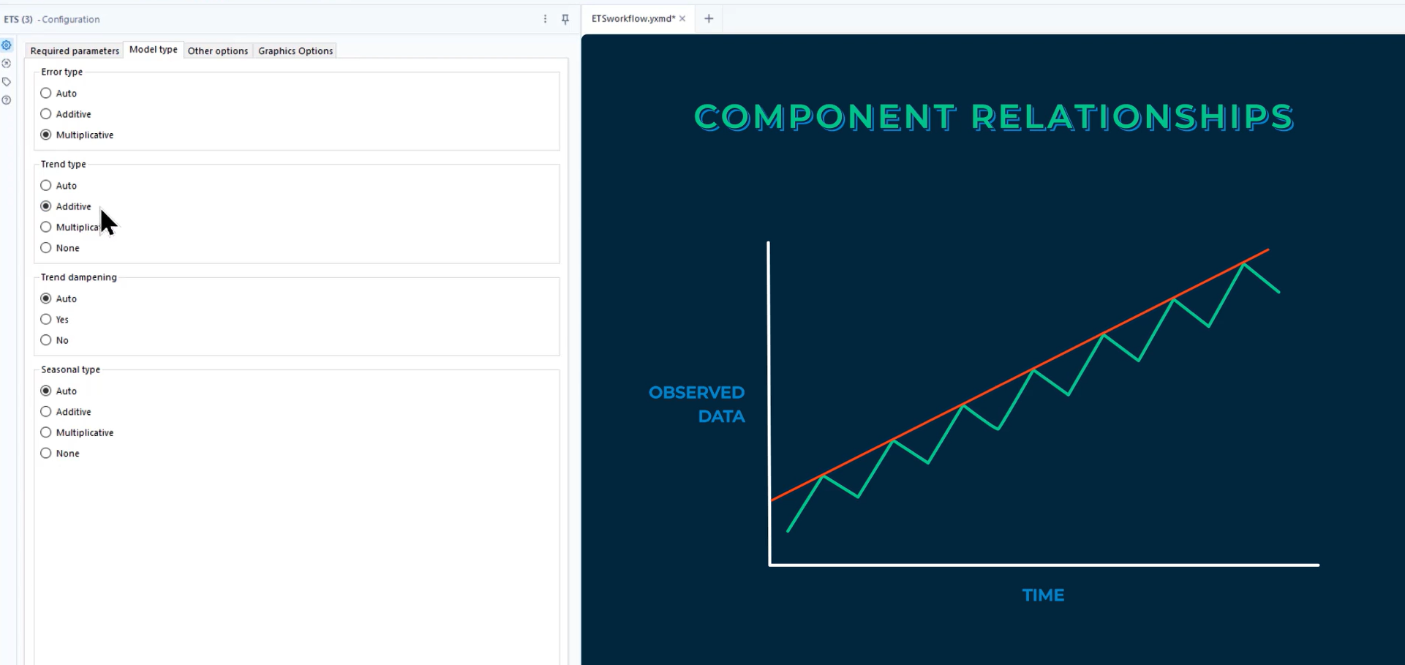

An exponential shape can indicate multiplicative trending.

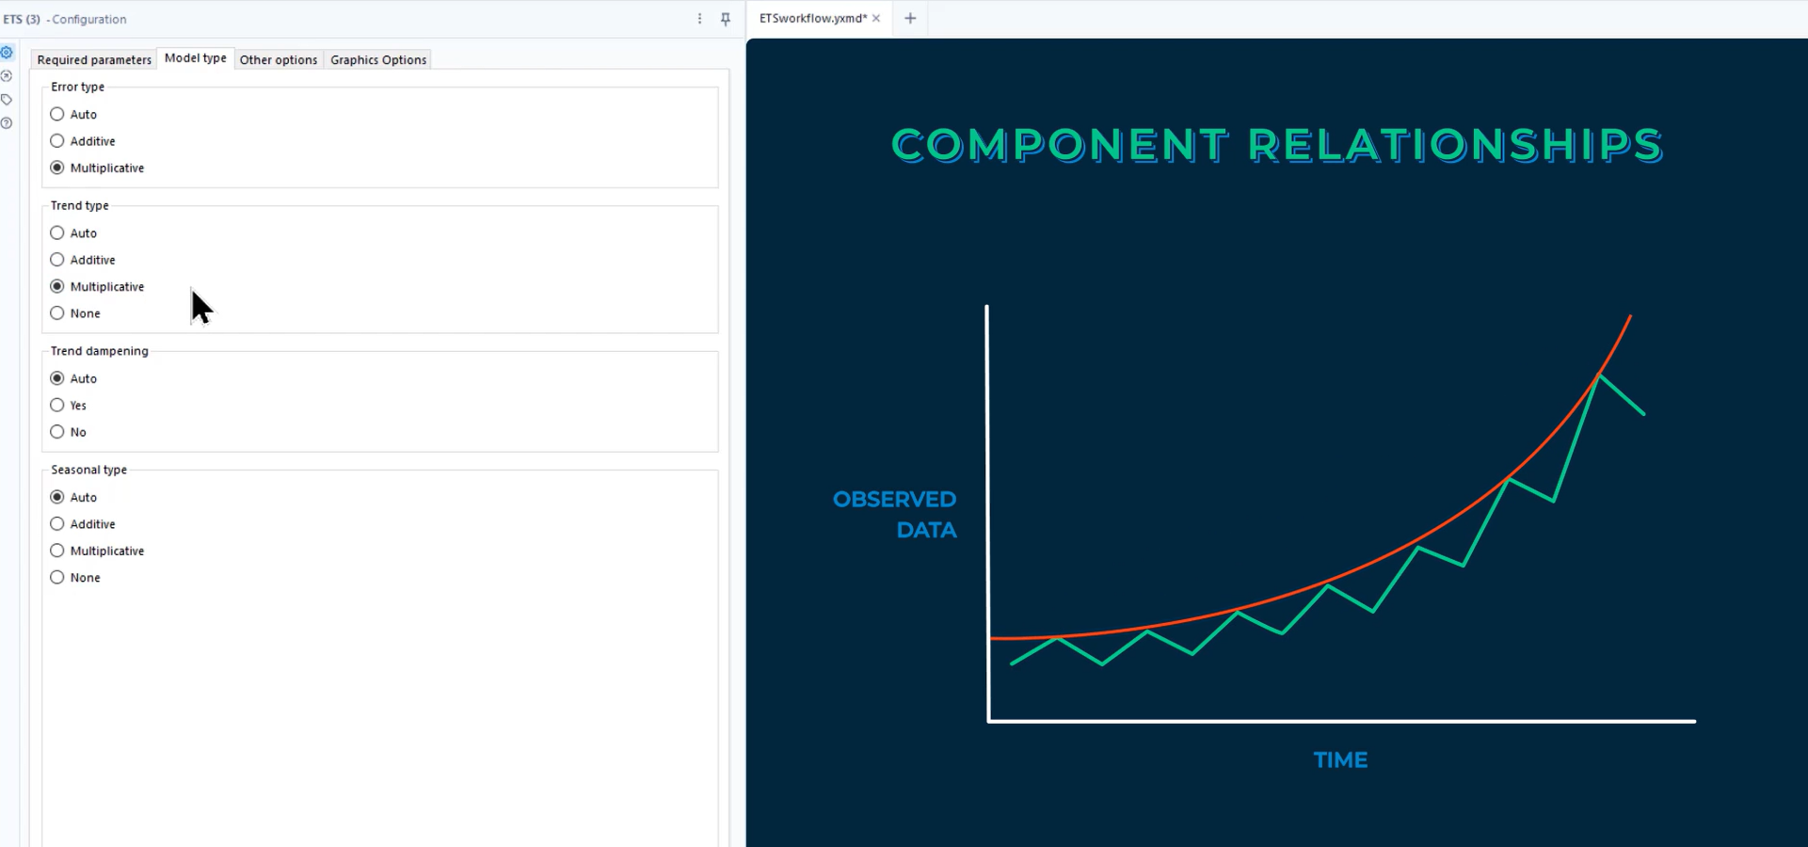

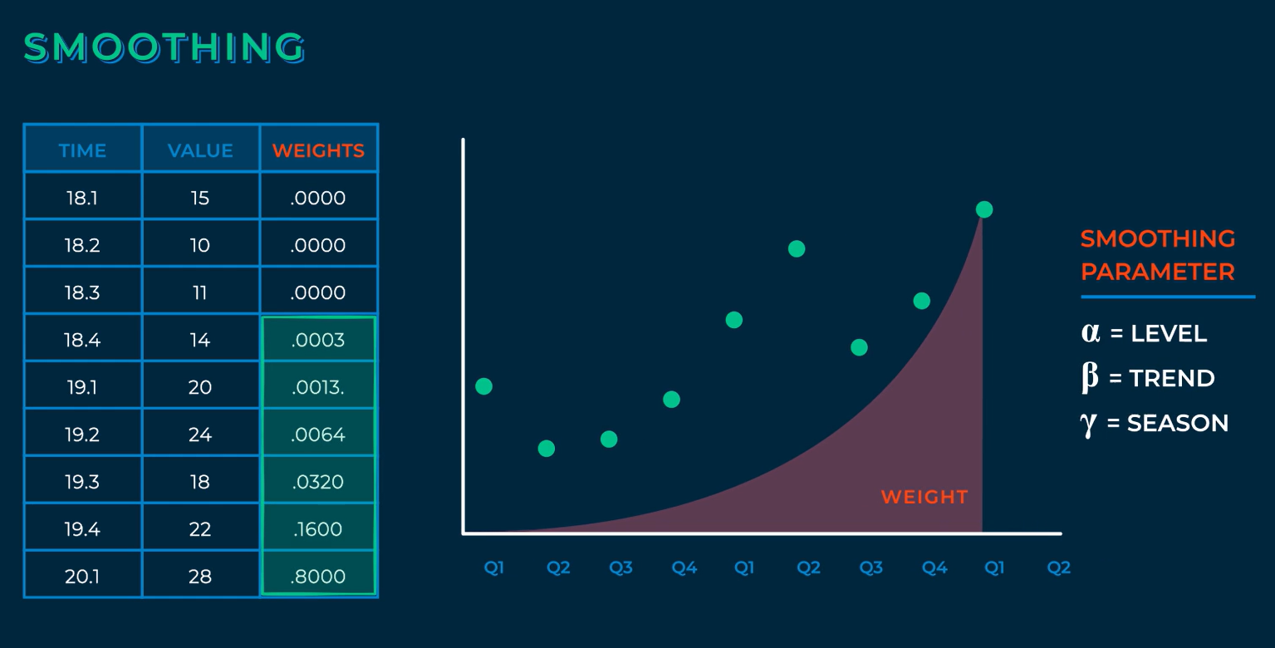

Phi is dampening.



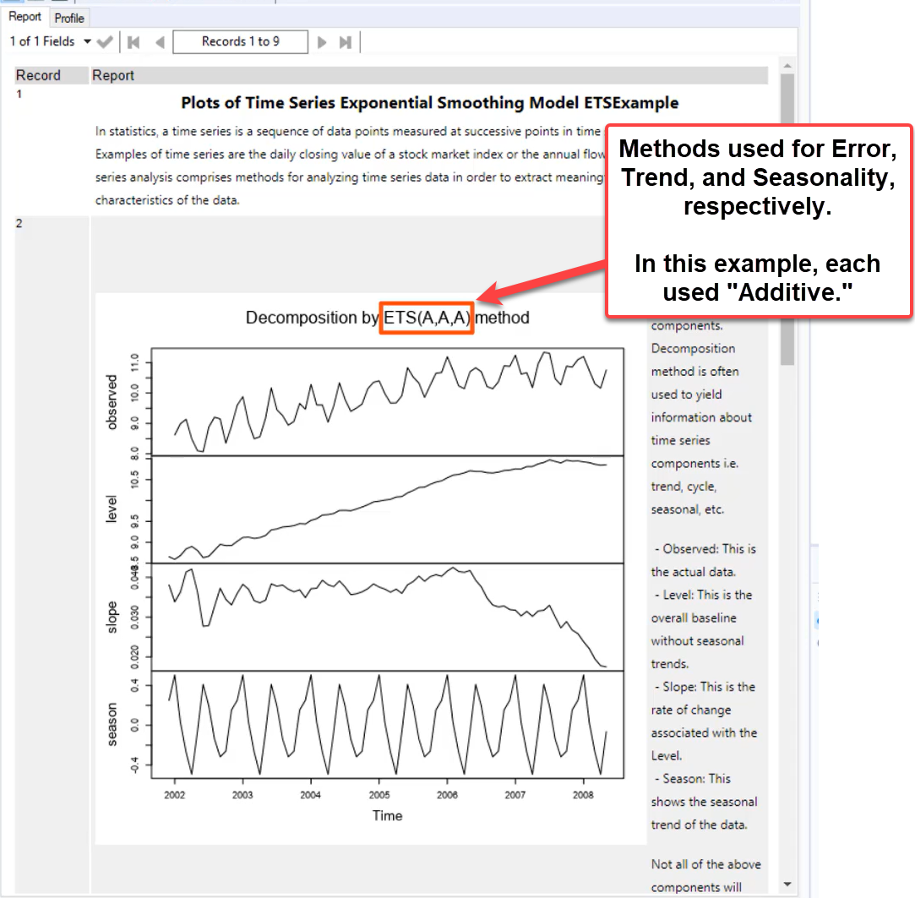

Trend may include a subscript to indicate dampening.

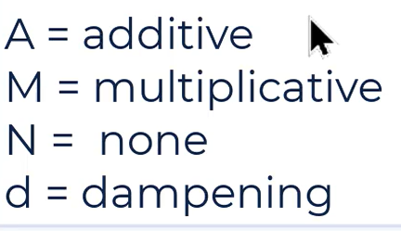

**ARIMA**

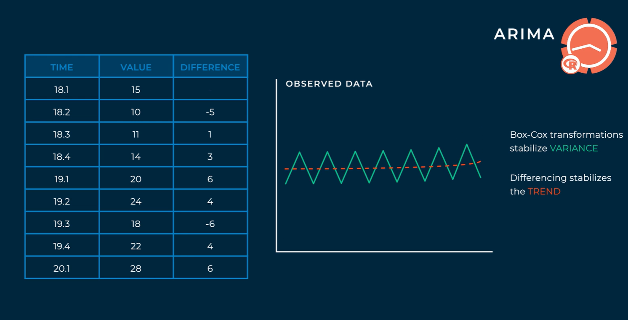

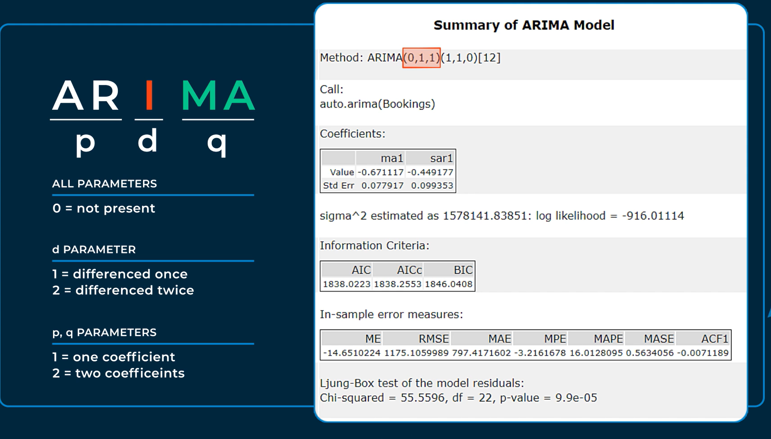

Seasonal components used capitalized P, D, and Q.

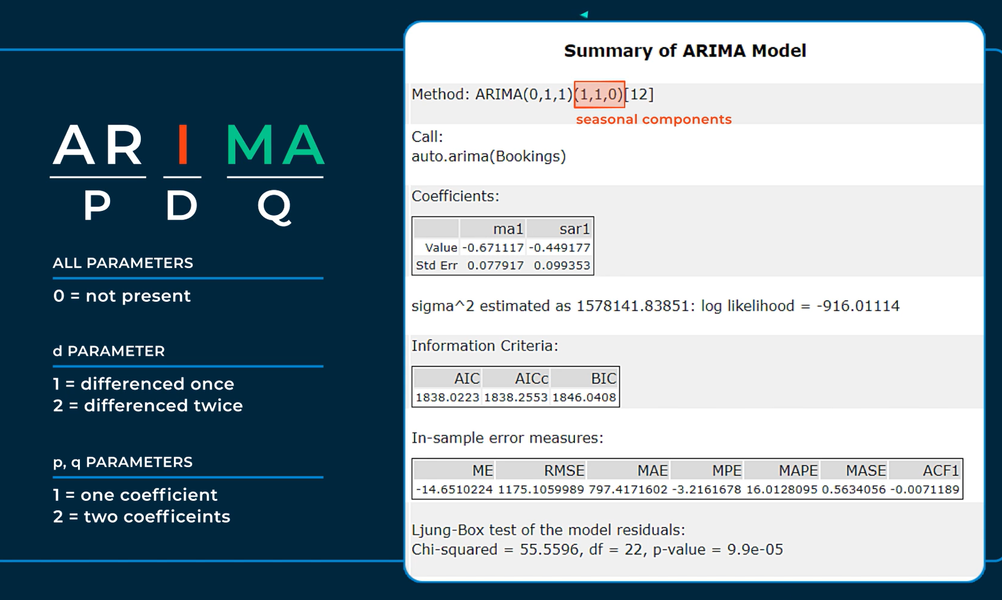

Periods in the seasonal cycle:

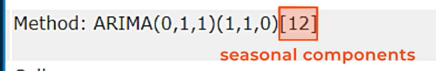

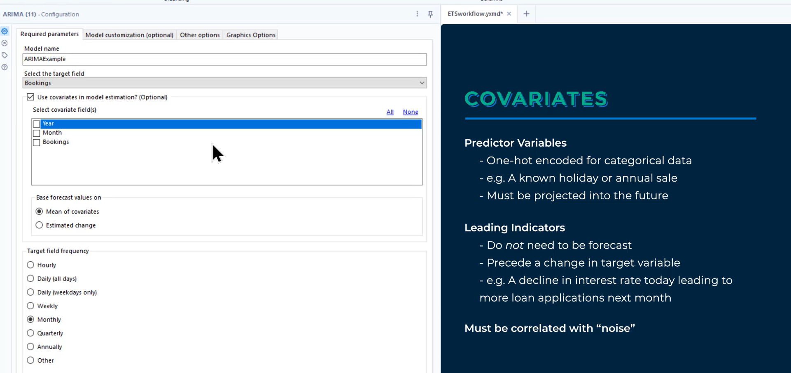

The “Do full enumeration of models (slow) instead of stepwise selection (faster)” check box will increase the time required to run the workflow but will allow the algorithm to compare more models when selecting the best performer.

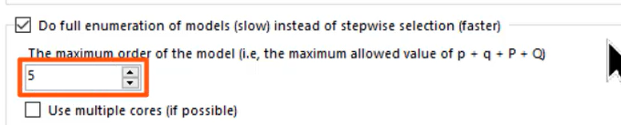

The “Allow drift” check box allows the final regression to have a constant value (similar to a y-intercept).

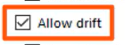

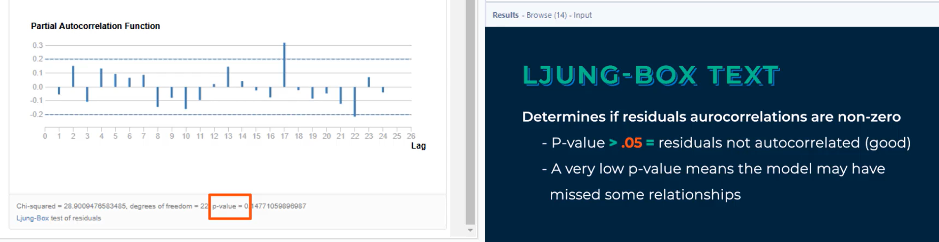

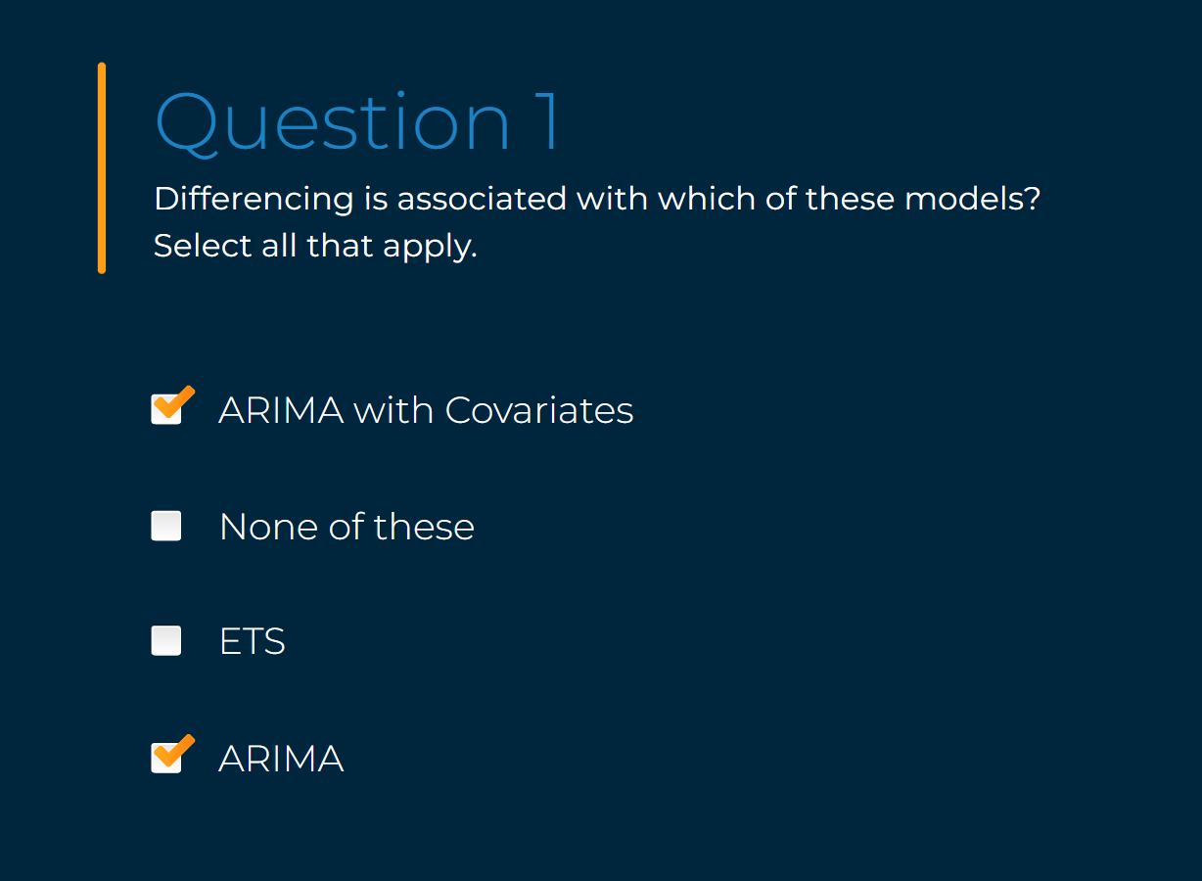

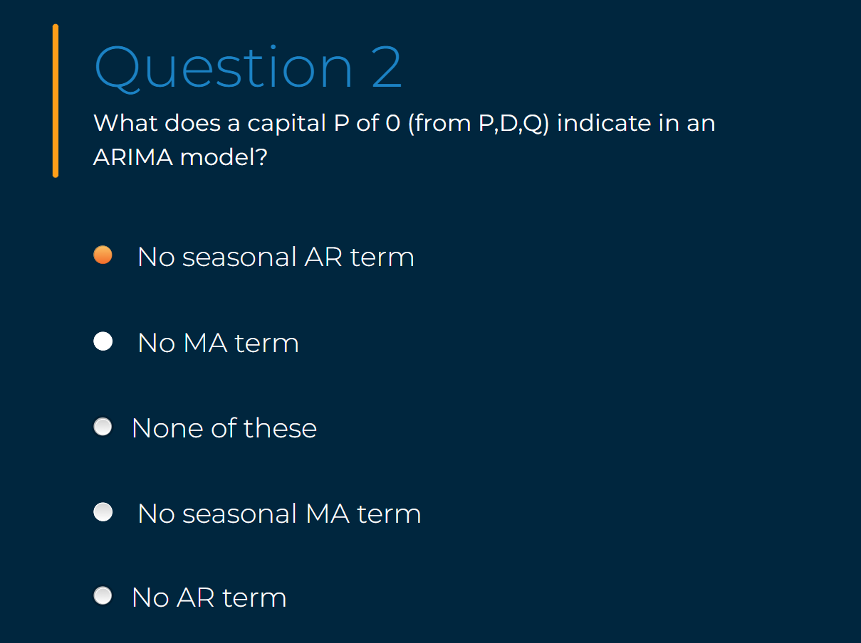

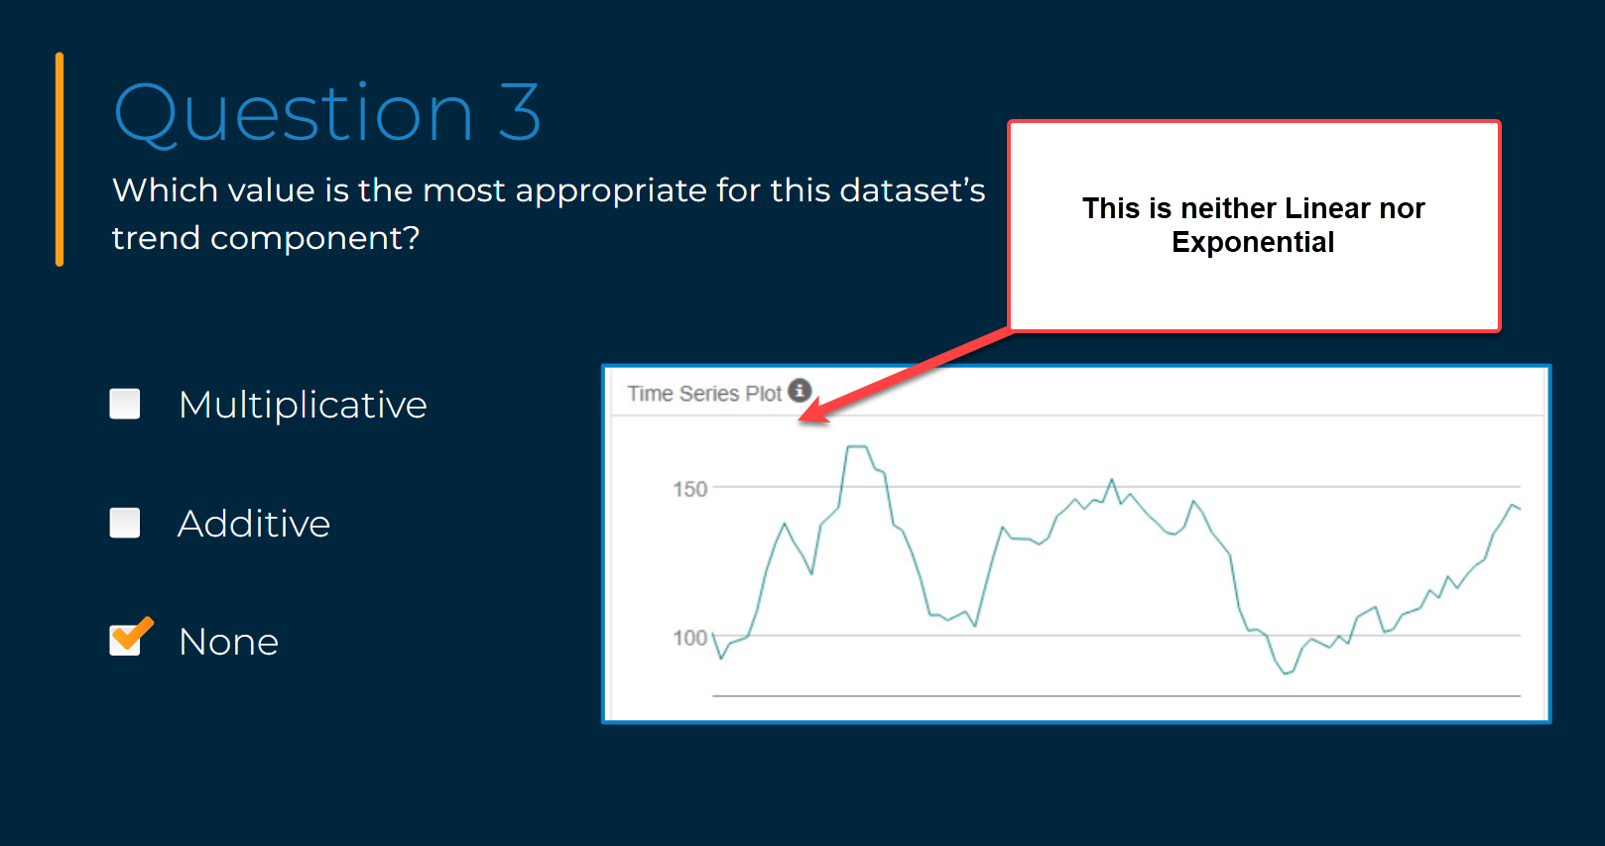

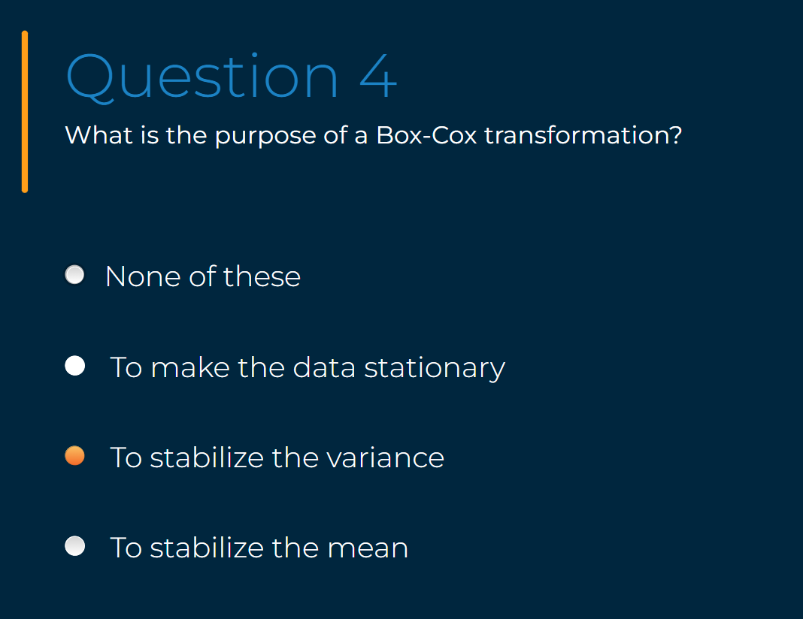

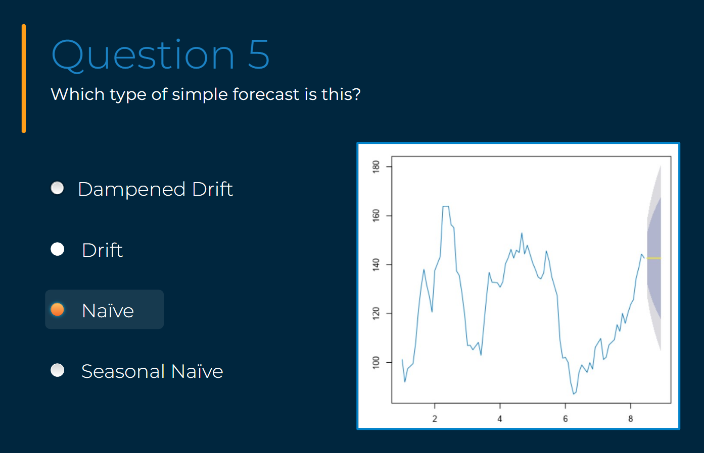

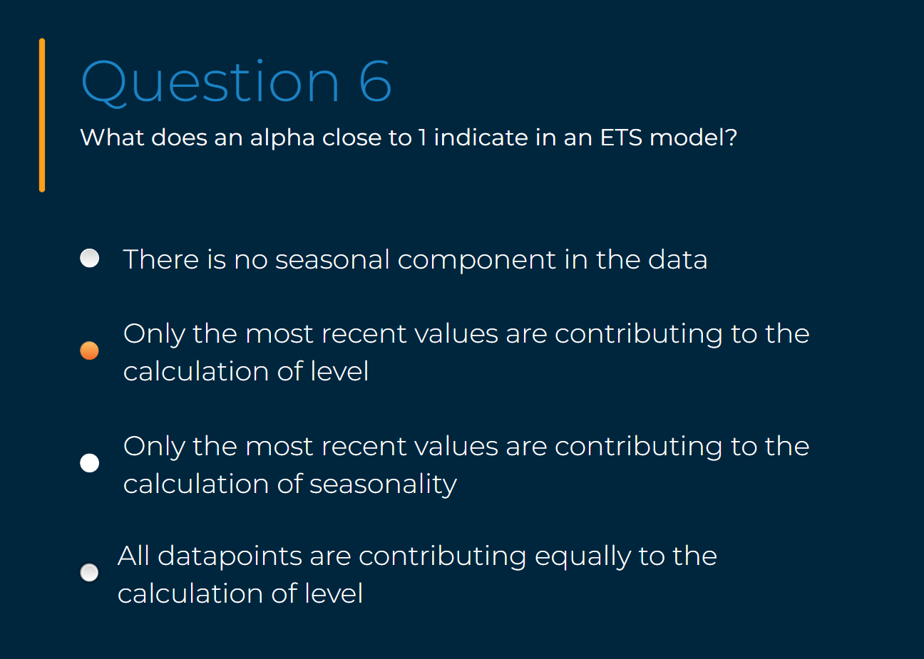

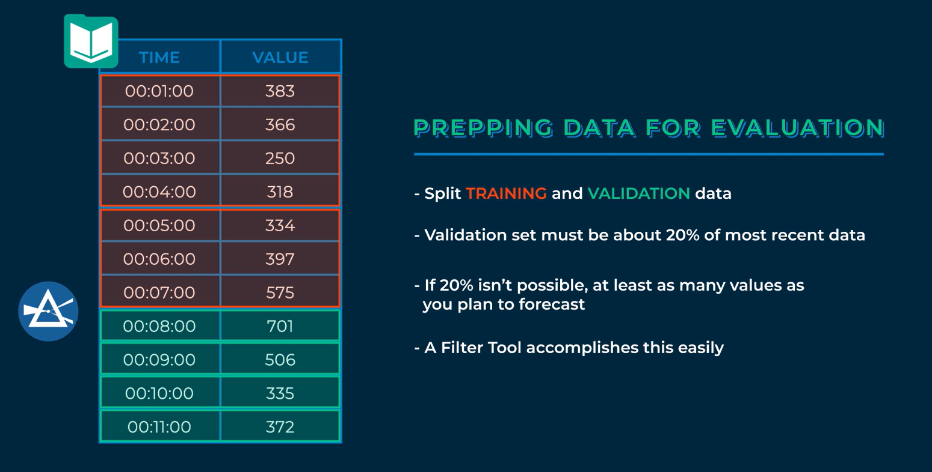

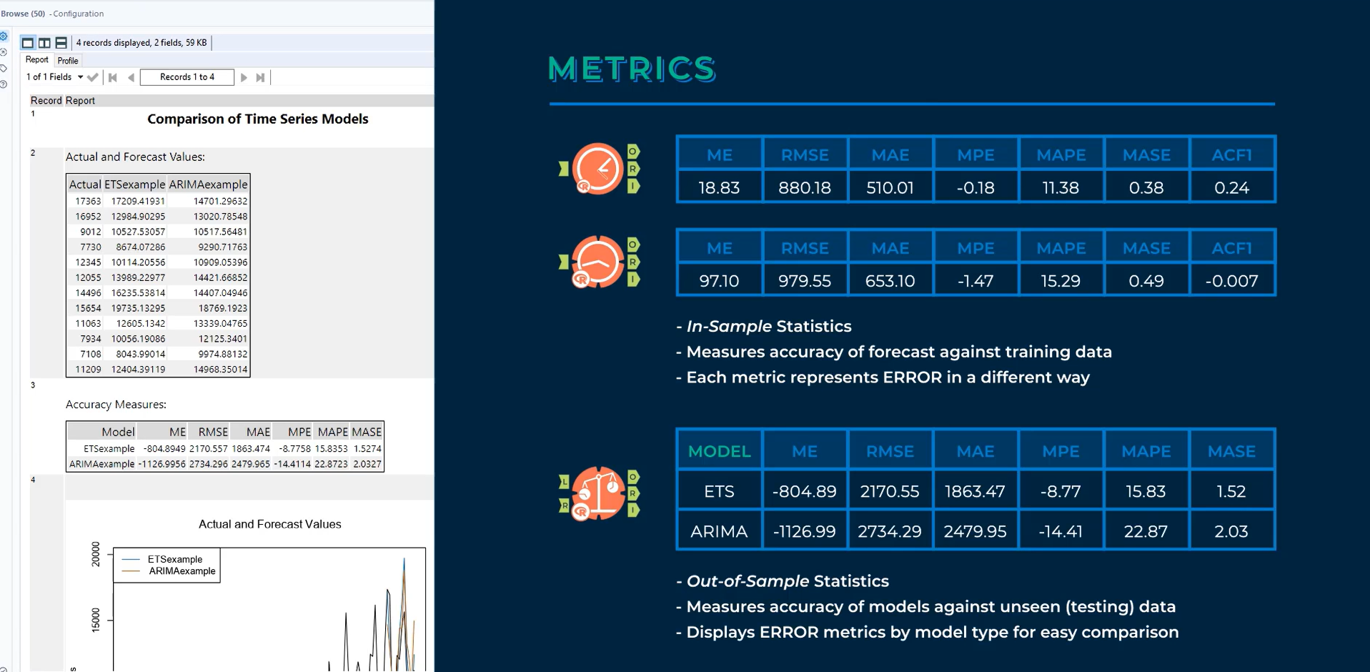

Scale dependent measurements such as RMSE and MAE should not be compared to models with different units.

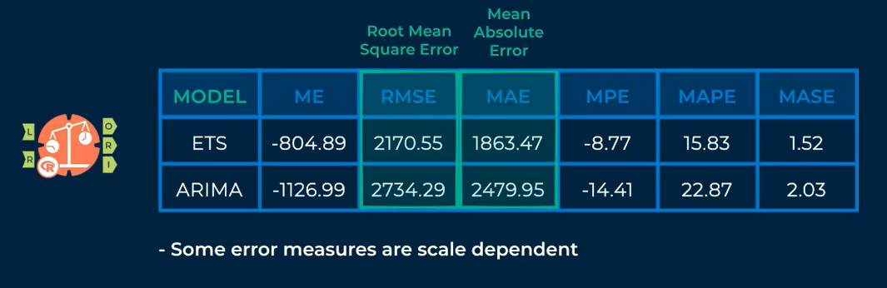

MPE and MAPE can be compared between models.

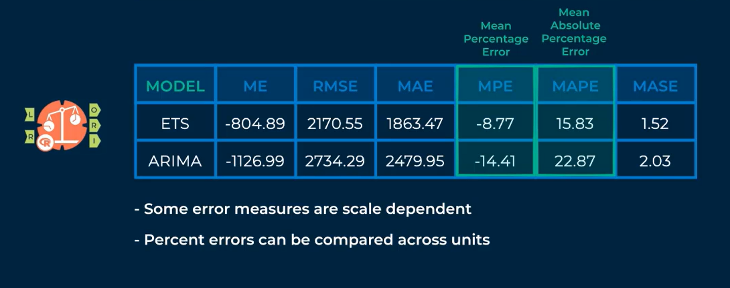

MASE is an alternative to percentage errors when comparing models created with different units.

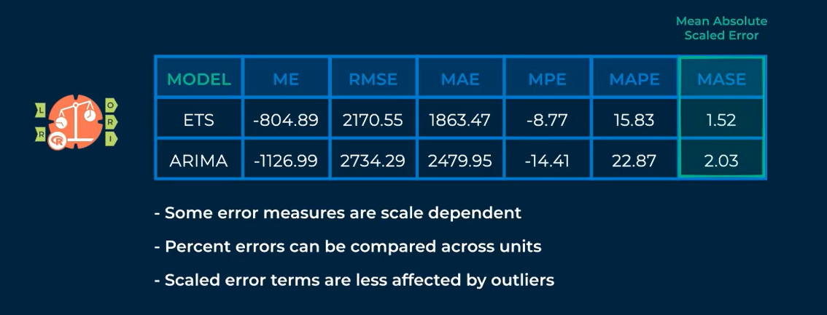

Values with the lowest absolute value indicate better performance.

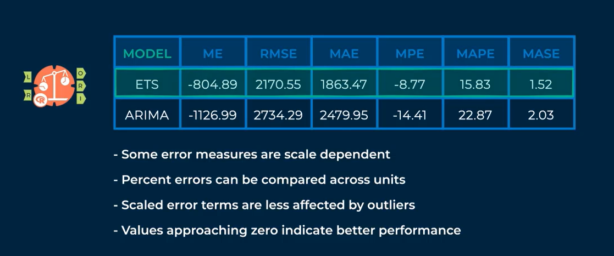

After selecting a model, a forecast is necessary. To make a forecast, use all of the data available (which includes the most recent values). Models compared may use only a training dataset (and compared using a validation dataset). See the screenshot below for an example.

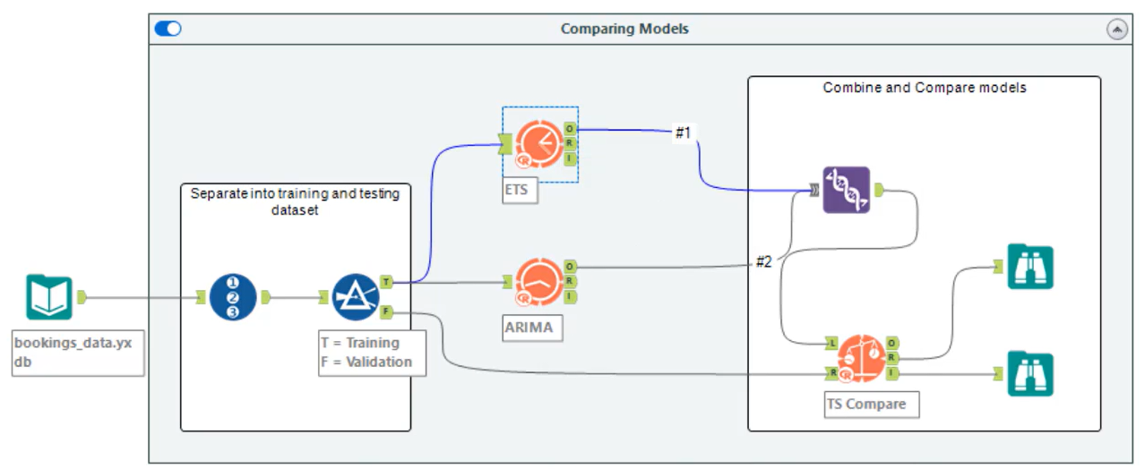

If using an ARIMA model with a covariate, the TS Covariate Forecast tool must be used. The data that go into the L input anchor should have the next time period at the top and the furthest time period at the bottom and the column header needs to match a column header in the original dataset. See the screenshot below for an example.

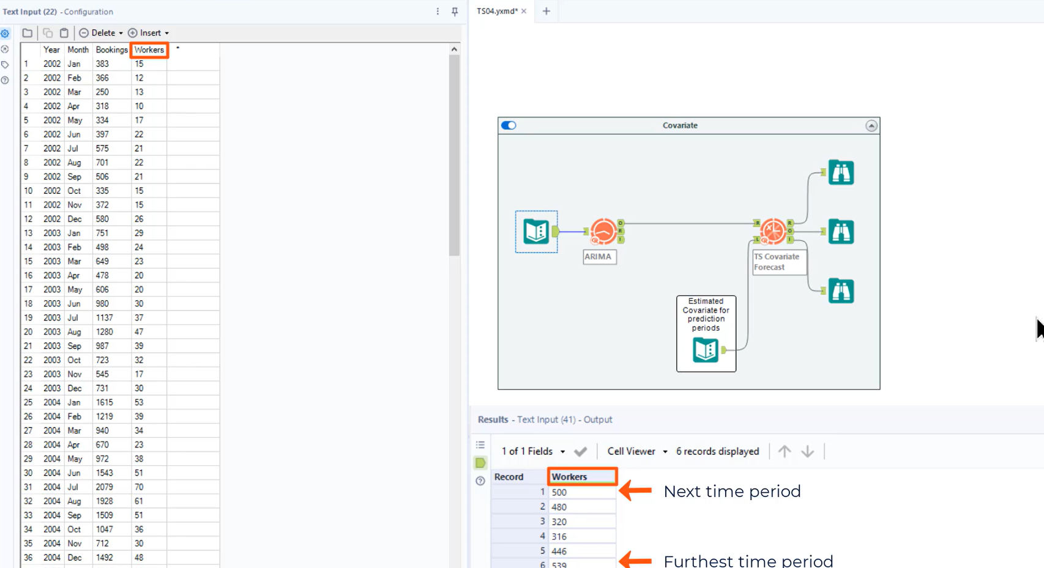

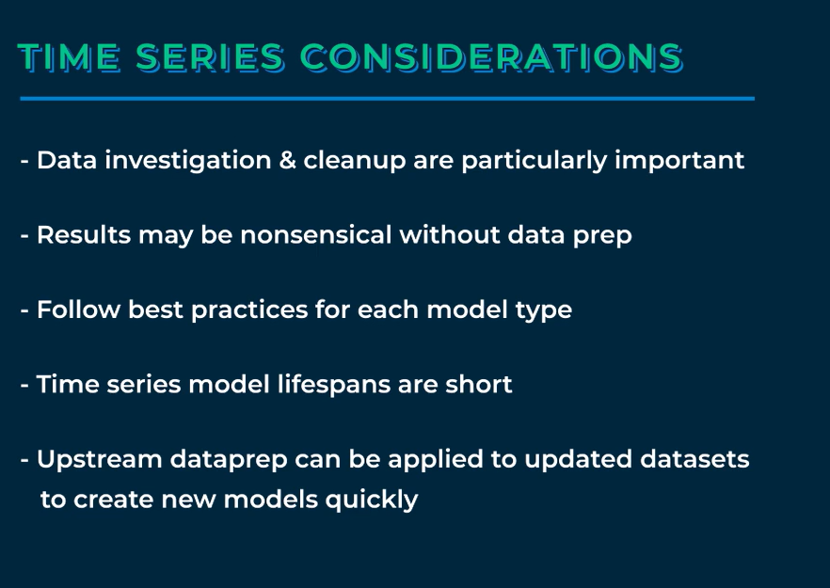

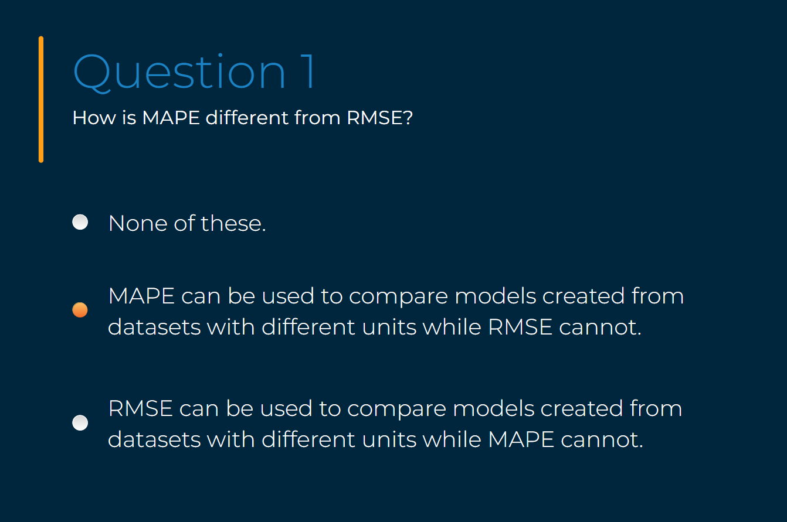

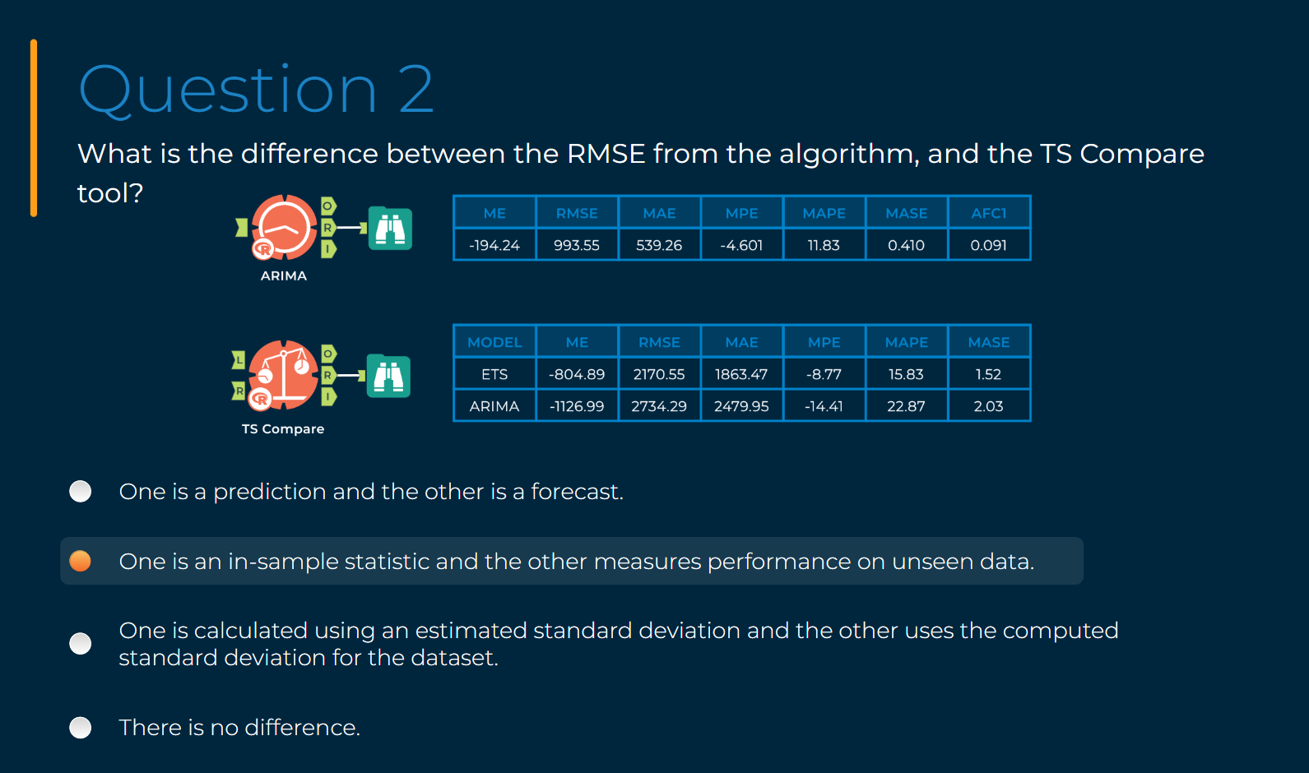

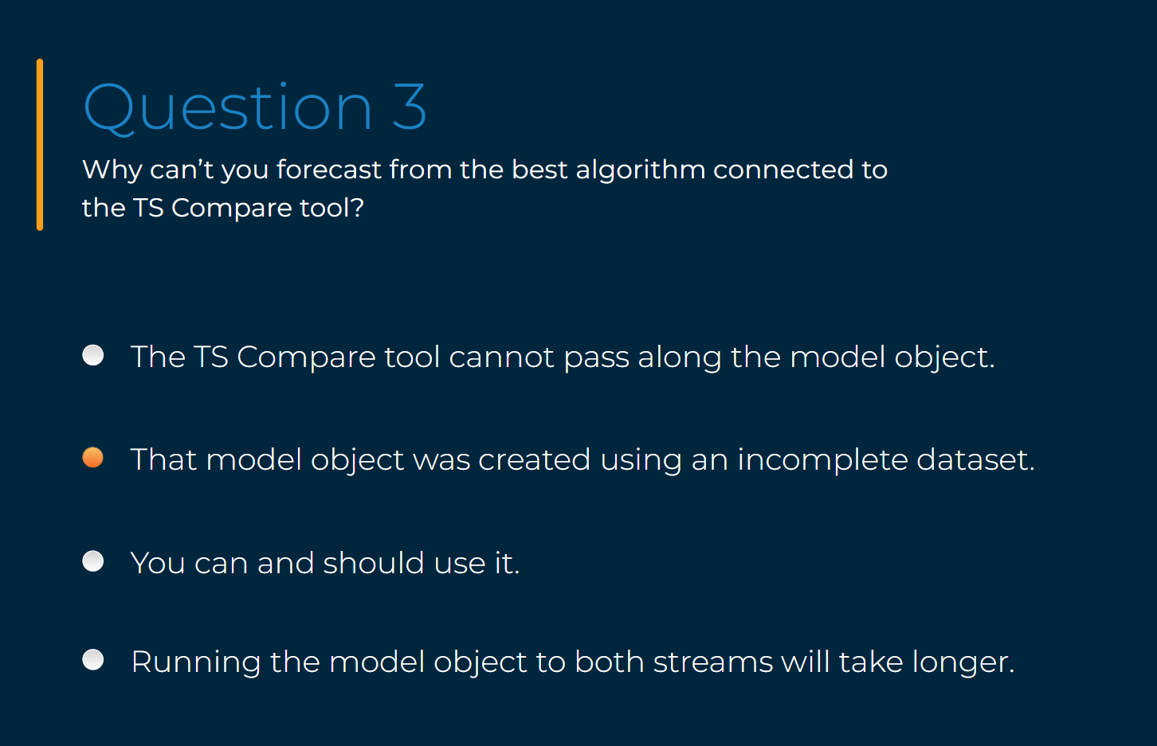

1. [The Akaike Information Criterion](https://timeseriesreasoning.com/contents/akaike-information-criterion/)
2. Examples

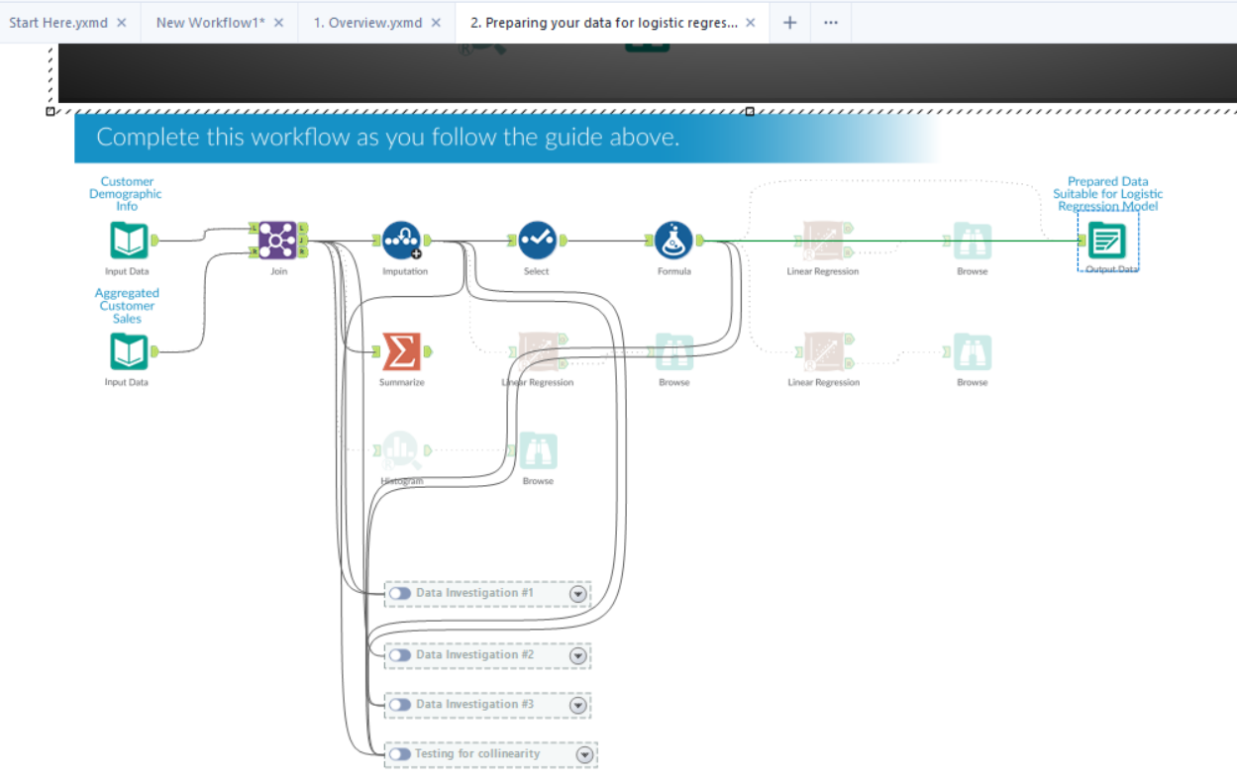

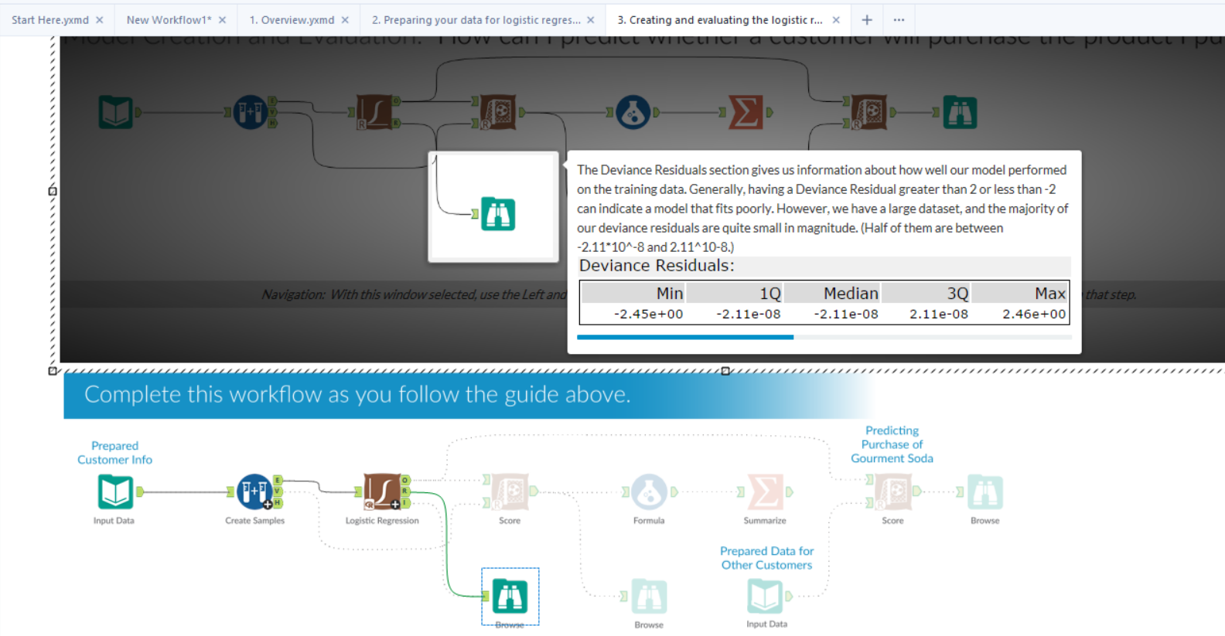

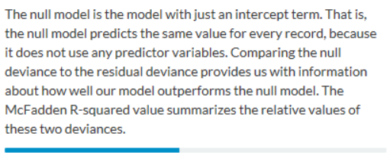

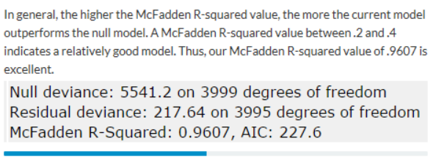

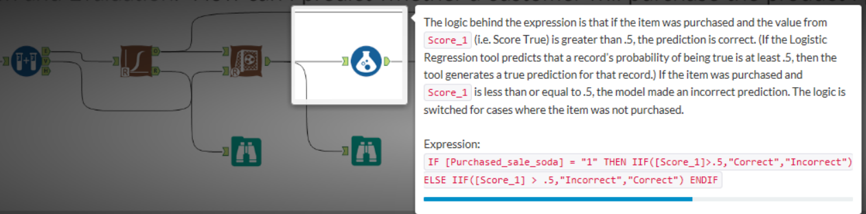

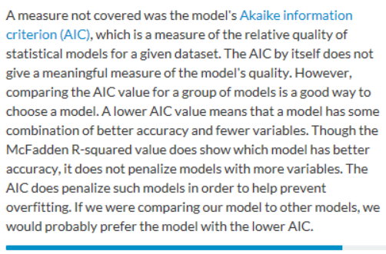

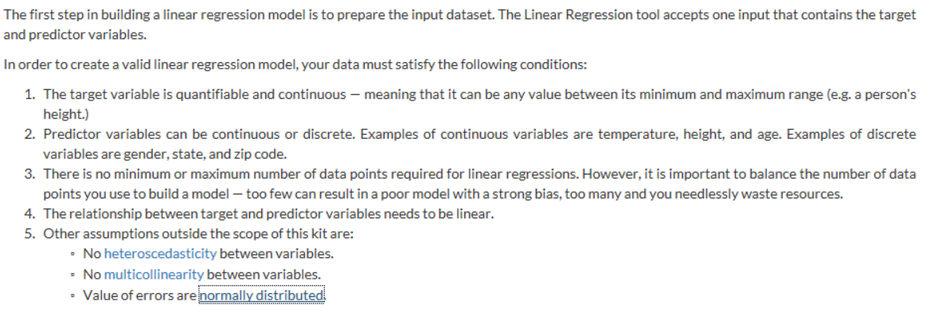

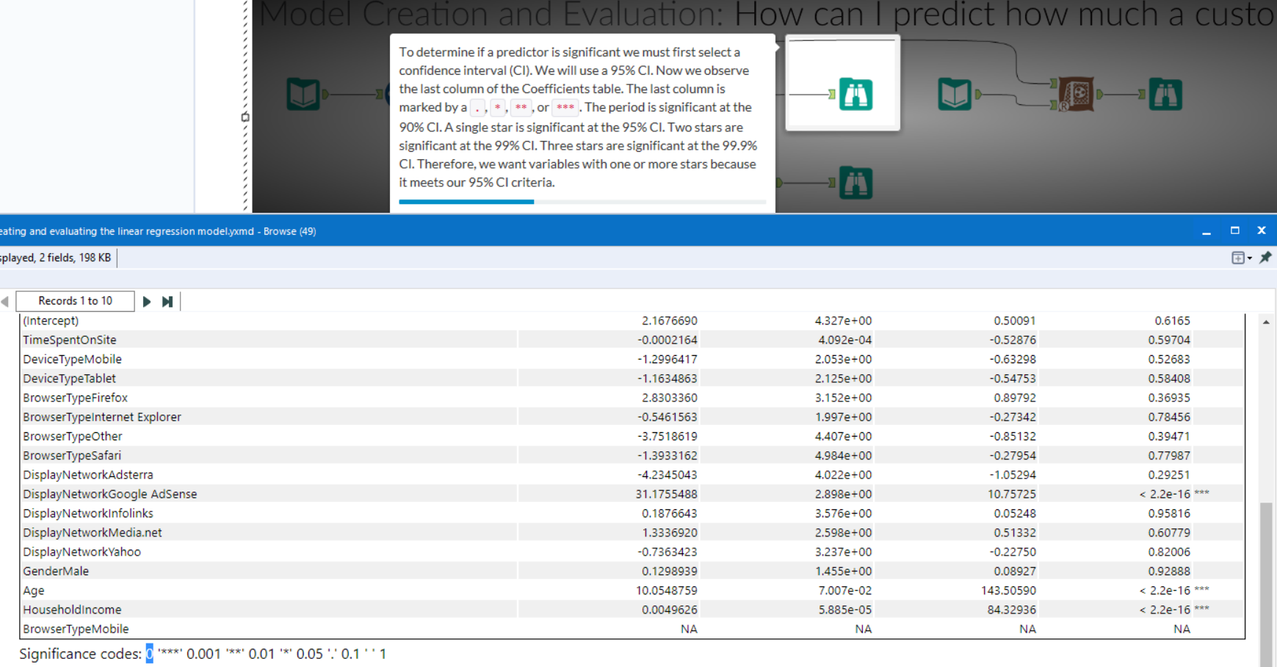

After deselecting fields that do not contribute to the model and rerunning the Linear Regression tool:

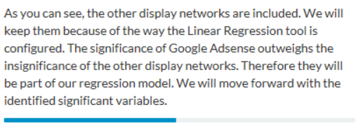

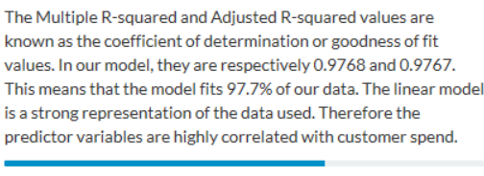

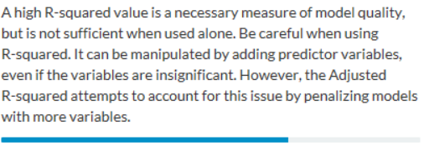

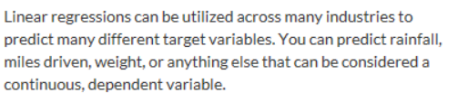

1. [Tool Mastery | Association Analysis](https://community.alteryx.com/t5/Alteryx-Designer-Knowledge-Base/Tool-Mastery-Association-Analysis/ta-p/40459)
2. [Tool Mastery | Score](https://community.alteryx.com/t5/Alteryx-Designer-Knowledge-Base/Tool-Mastery-Score/ta-p/179436)
3. [Pre-Predictive: Using the Data Investigation Tools - Part 3 of 4](https://community.alteryx.com/t5/Alteryx-Designer-Knowledge-Base/Pre-Predictive-Using-the-Data-Investigation-Tools-Part-3-of-4/ta-p/100909)
4. [Box plot](https://en.wikipedia.org/wiki/Box_plot)
5. [Weekly Challenge #157: An Expert Challenge](https://community.alteryx.com/t5/Weekly-Challenge/Challenge-157-An-Expert-Challenge/td-p/393423)
6. Linear Regressions and categorical variables

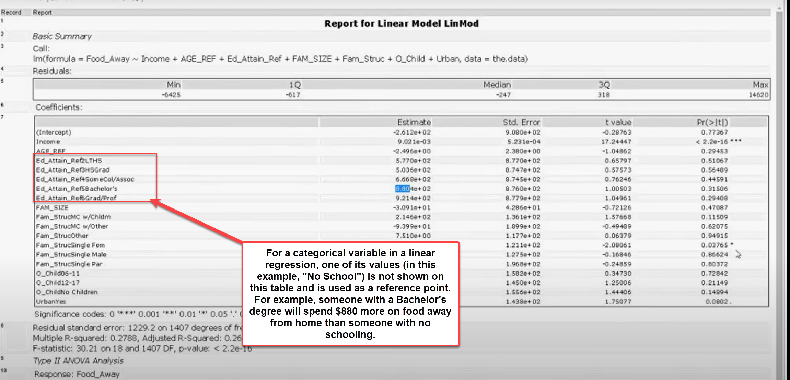

1. Example of a classification problem, from [Regression Modeling](https://community.alteryx.com/t5/Archived-Training/Regression-Modeling/td-p/43712):

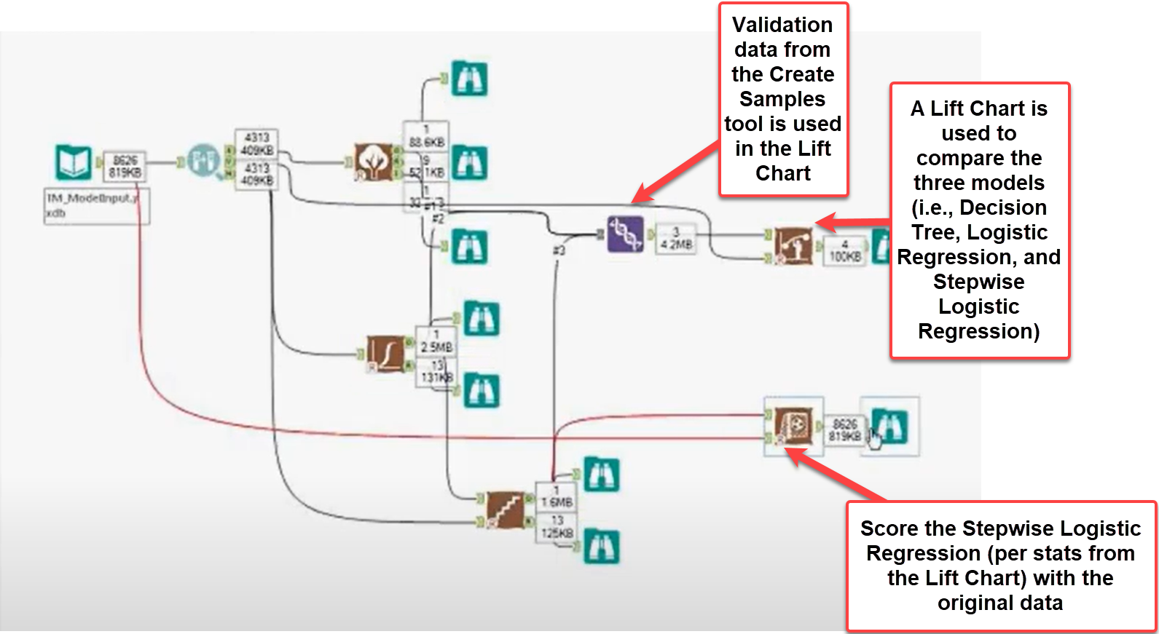

Decision Tree:

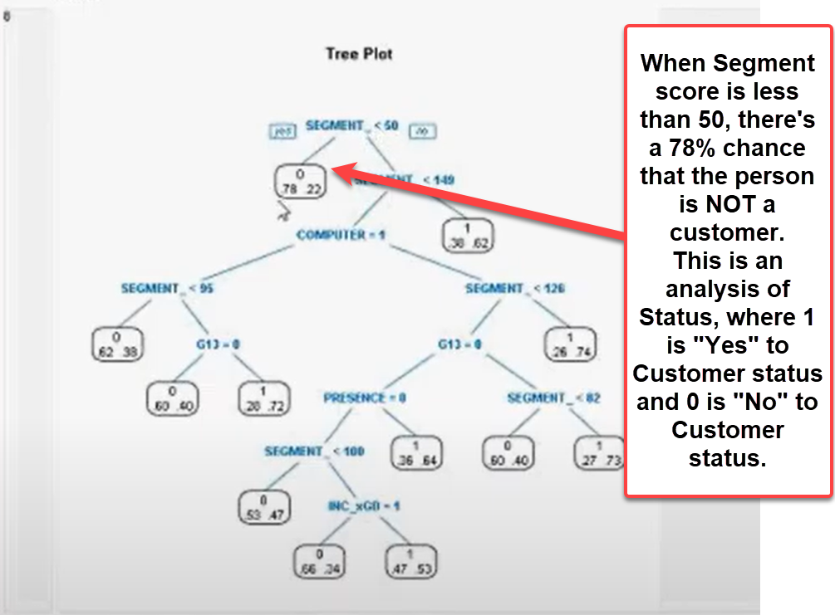

1. Basic K-Means:

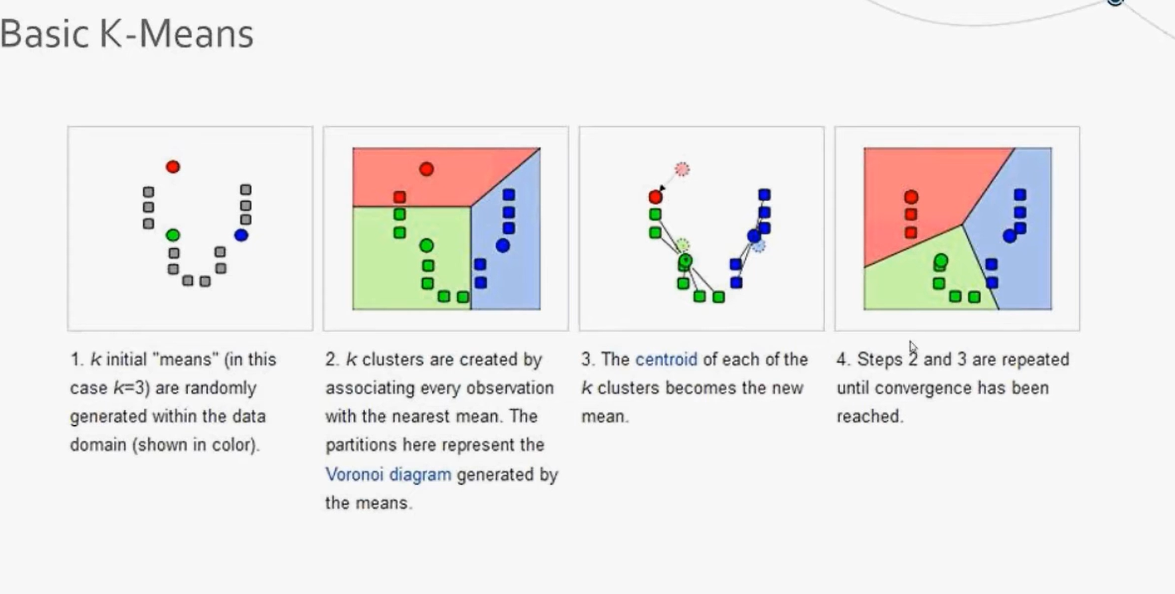

1. [Cluster Analysis Basics](https://community.alteryx.com/t5/Archived-Training/Cluster-Analysis-Basics/td-p/47175)
2. Data Investigation/Prep (Key Terms):

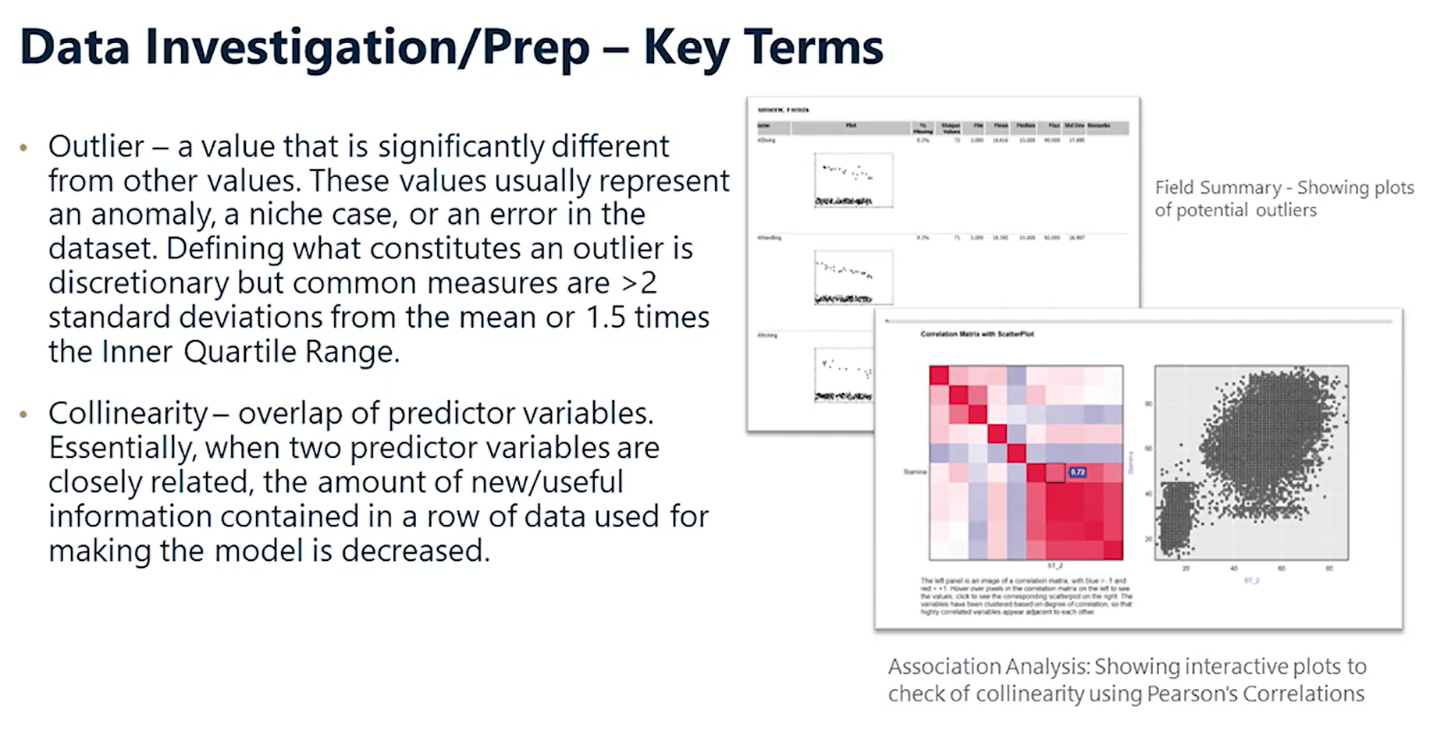

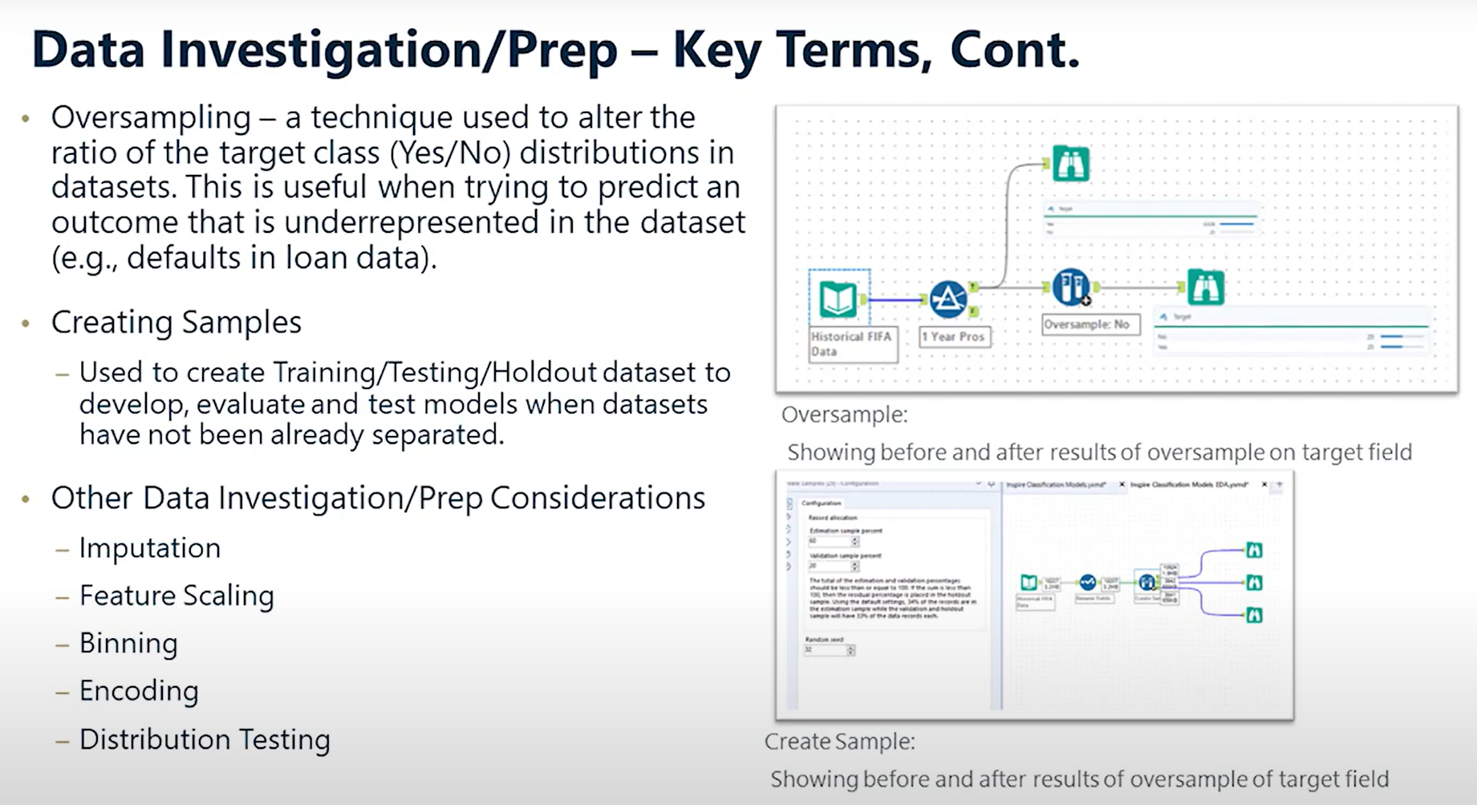

1. Logistic Regression characteristics:

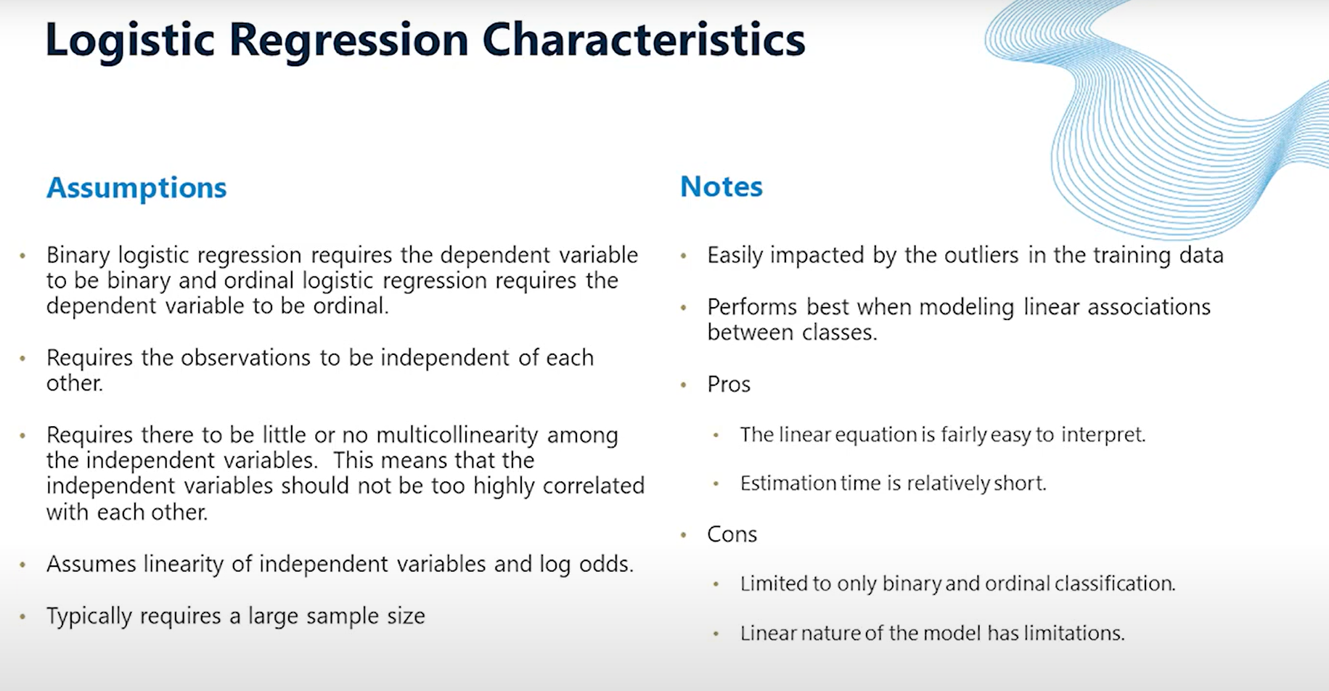

1. [Predictive Modeling: Classification](https://community.alteryx.com/t5/Archived-Training/Predictive-Modeling-Classification/td-p/824974)

# Analytic Applications & Macros

1. [Reference shortcuts (and why you should be using them)](https://community.alteryx.com/t5/Engine-Works/What-Are-Reference-Shortcuts-And-Why-You-Should-Be-Using-Them/ba-p/921485)
2. [User constants changed from interface tools](https://community.alteryx.com/t5/Alteryx-Designer-Discussions/User-Constants-changed-from-intercface-tools/m-p/12747)
3. [Advanced Macro Development](https://community.alteryx.com/t5/Videos/Advanced-Macro-Development/td-p/43862)
4. [Weekly Challenge #39: Trouble Shooting a Broken Macro](https://community.alteryx.com/t5/Weekly-Challenge/Challenge-39-Trouble-Shooting-a-Broken-Macro/m-p/36580)
5. [Weekly Challenge #74: Build a Factorial Calculator](https://community.alteryx.com/t5/Weekly-Challenge/Challenge-74-Build-a-Factorial-Calculator/td-p/65932)
6. [Weekly Challenge #118: Think Like a CSE - A not-so-wild-wildcard input!](https://community.alteryx.com/t5/Weekly-Challenge/Challenge-118-Think-Like-a-CSE-A-not-so-wild-wildcard-input/td-p/167049)
7. [Weekly Challenge #140: Prove the Birthday Paradox!](https://community.alteryx.com/t5/Weekly-Challenge/Challenge-140-Prove-the-Birthday-Paradox/td-p/320958)
8. [Weekly Challenge #240: Every Vote Counts!](https://community.alteryx.com/t5/Weekly-Challenge/Challenge-240-Every-Vote-Counts/td-p/659897)
9. [Weekly Challenge #246: Rectangle Tangle](https://community.alteryx.com/t5/Weekly-Challenge/Challenge-246-Rectangle-Tangle/m-p/680194)
10. [CS Macro Dev: Conditional Processing with Detours](https://community.alteryx.com/t5/Alteryx-Designer-Knowledge-Base/CS-Macro-Dev-Conditional-Processing-with-Detours/ta-p/12315)
11. [CS Macro Dev: Iterative Macros](https://community.alteryx.com/t5/Alteryx-Designer-Knowledge-Base/CS-Macro-Dev-Iterative-Macros/ta-p/10303)
    1. The example shown in the link above briefly goes over a very complicated and arduous way to solve the knapsack problem. The article was written before the Optimization tool existed in Alteryx. Nowadays, a much simpler, more efficient approach to solving this problem is by creating a batch macro that loops over the number of boxes to test. It will return the results of, “What is/are the best boxes to take from 1 to n?” This assumes you can use a box once and only once (i.e., you can’t use multiple of a box). Creating a batch macro that allows the user to select (via a Check Box tool) whether the upper bound should be infinity (i.e., a single box can be used as many times as the constraint(s) allow) allows us to answer more variations to the knapsack problem.
12. Search tags for a macro can be added within the “Meta Info” tab:

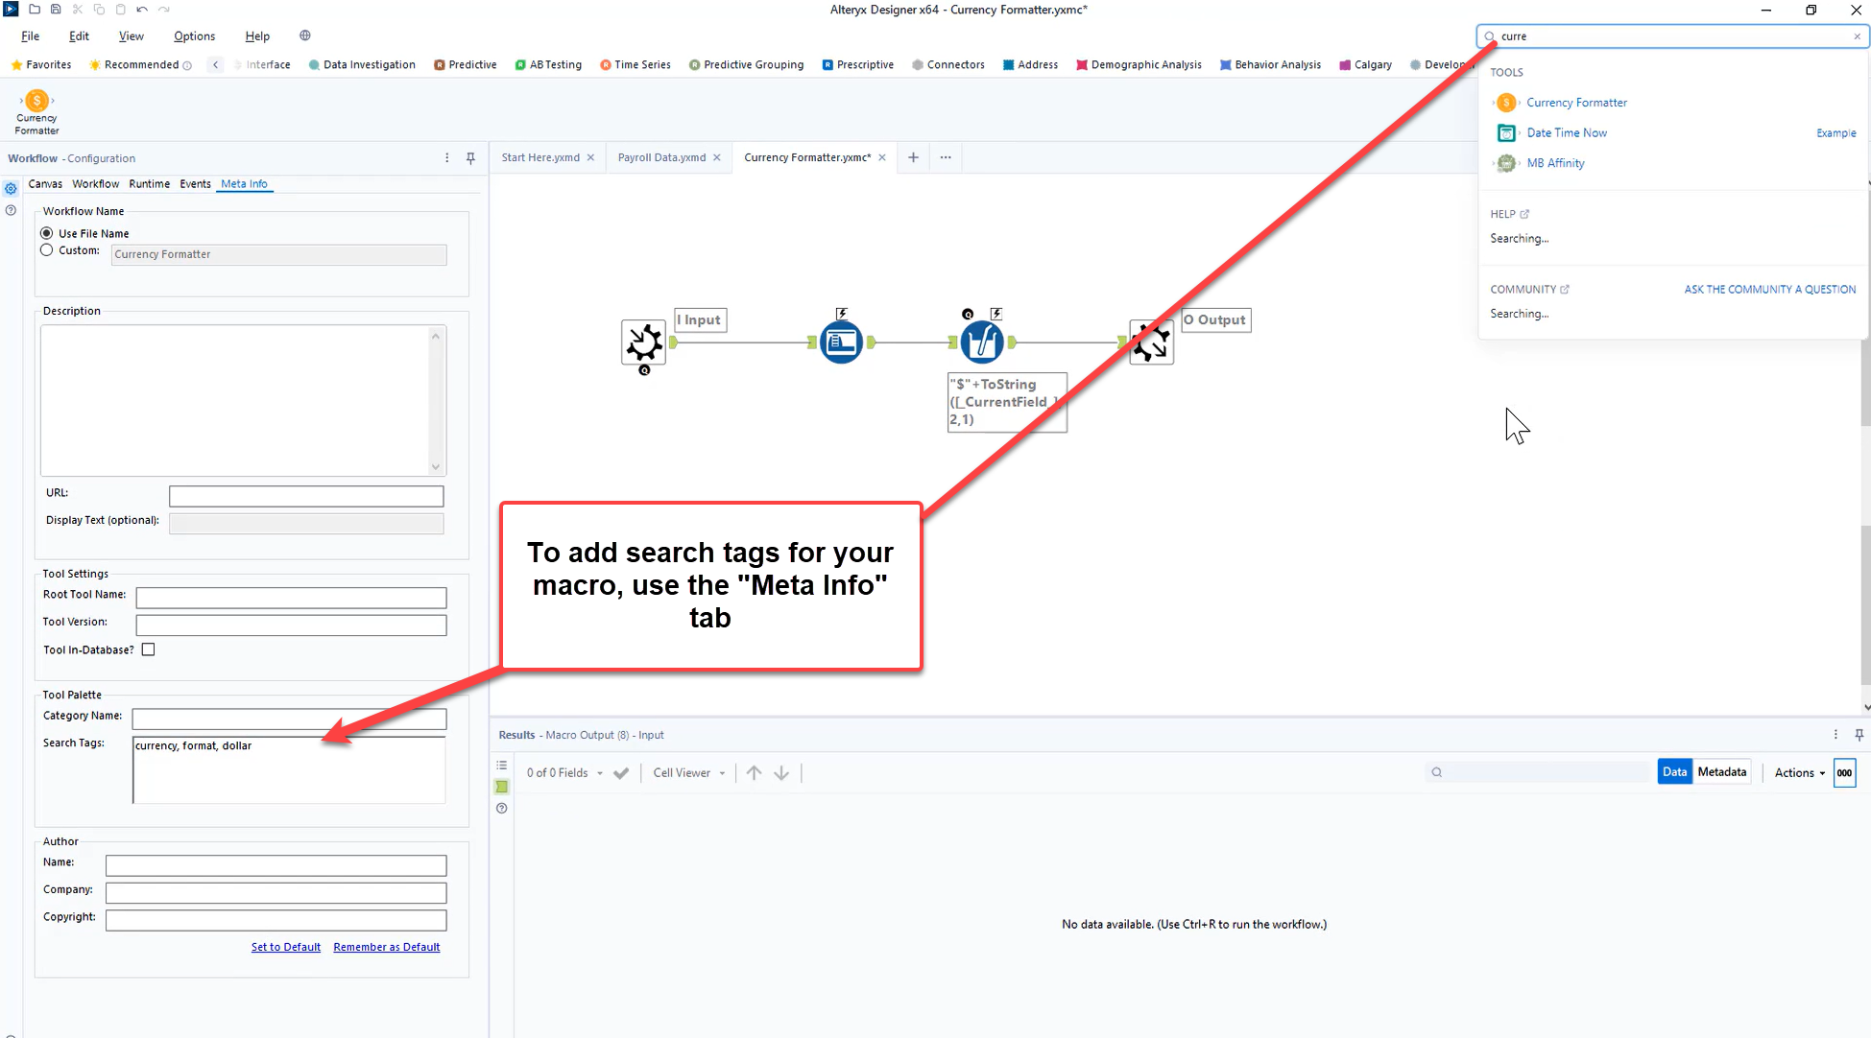

1. Example of editing the XML of a tool by using the selections from a List Box tool:

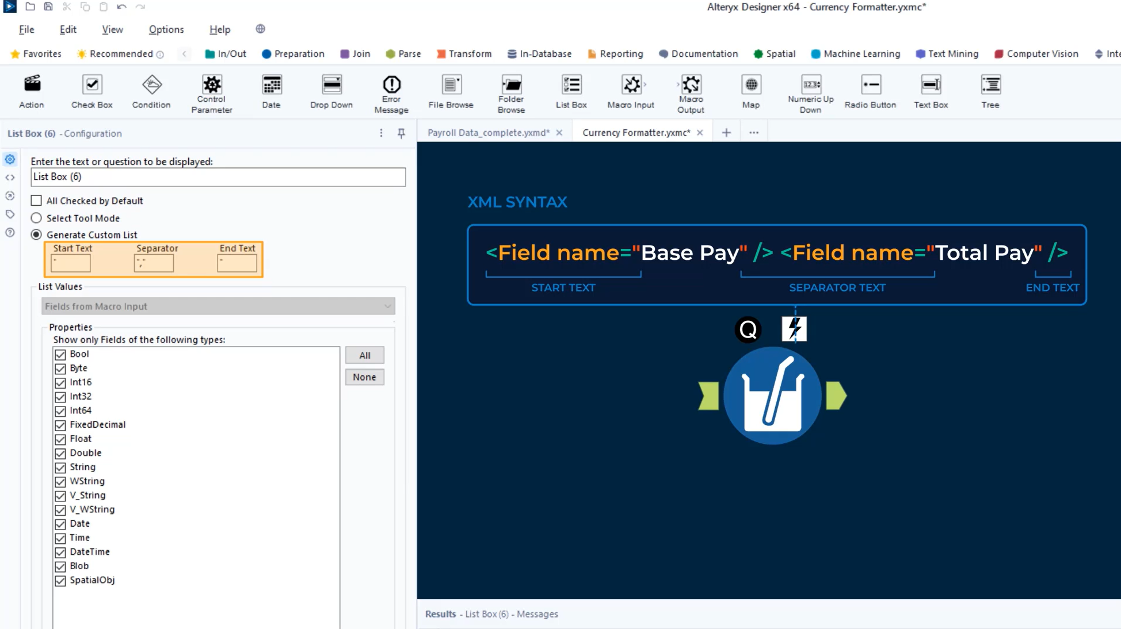

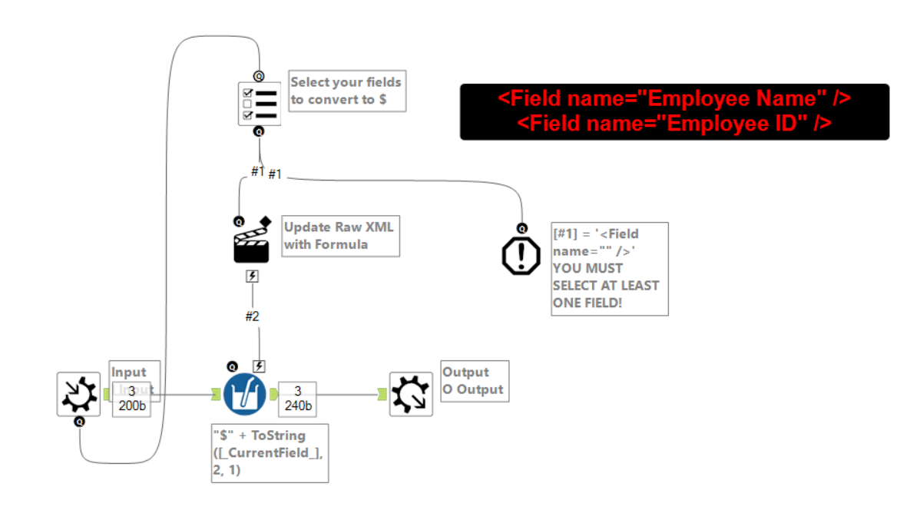

1. [Building dynamic workflows with detour tools or updating XML](https://www.altertricks.com/expert/building-dynamic-workflows-with-detour-tools-or-updating-xml/)
2. Batch macro grouping:

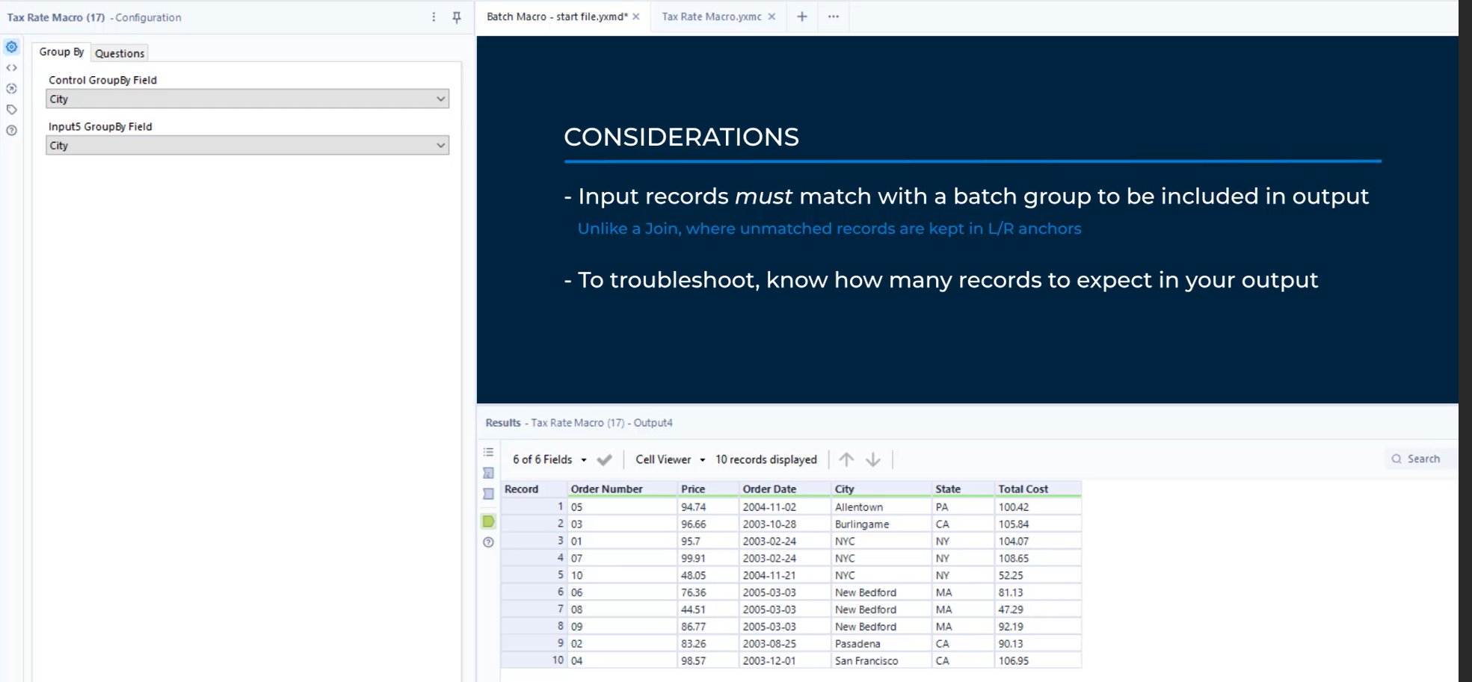

1. [Update Raw XML in Alteryx Macros](https://www.thedataschool.com.au/ryan-edwards/update-raw-xml-in-alteryx-macros/)
2. [Getting Started with Batch Macros](https://community.alteryx.com/t5/Alteryx-Designer-Knowledge-Base/Getting-Started-with-Batch-Macros/ta-p/488165)
3. Tools with an expression editor can be updated with questions:

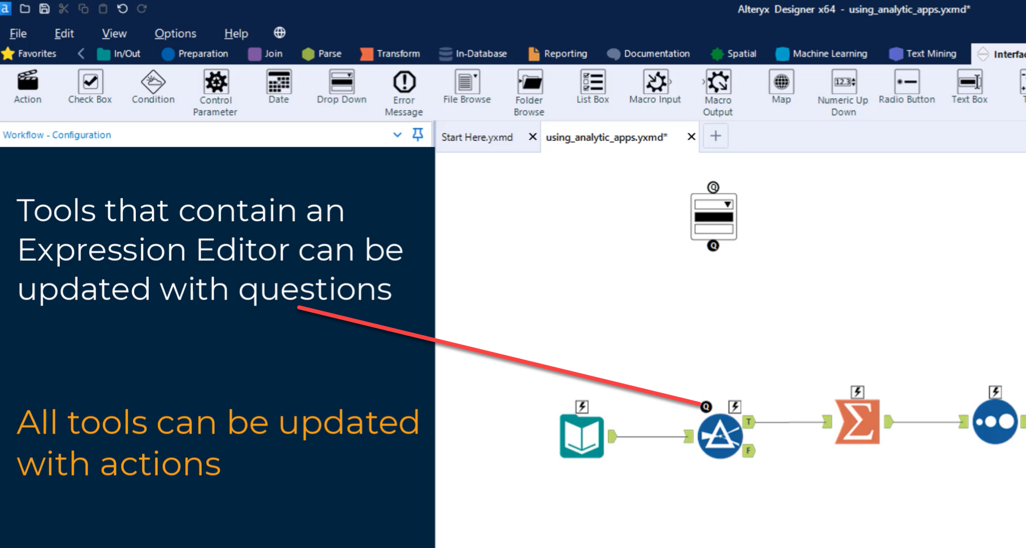

1. List Box questions:

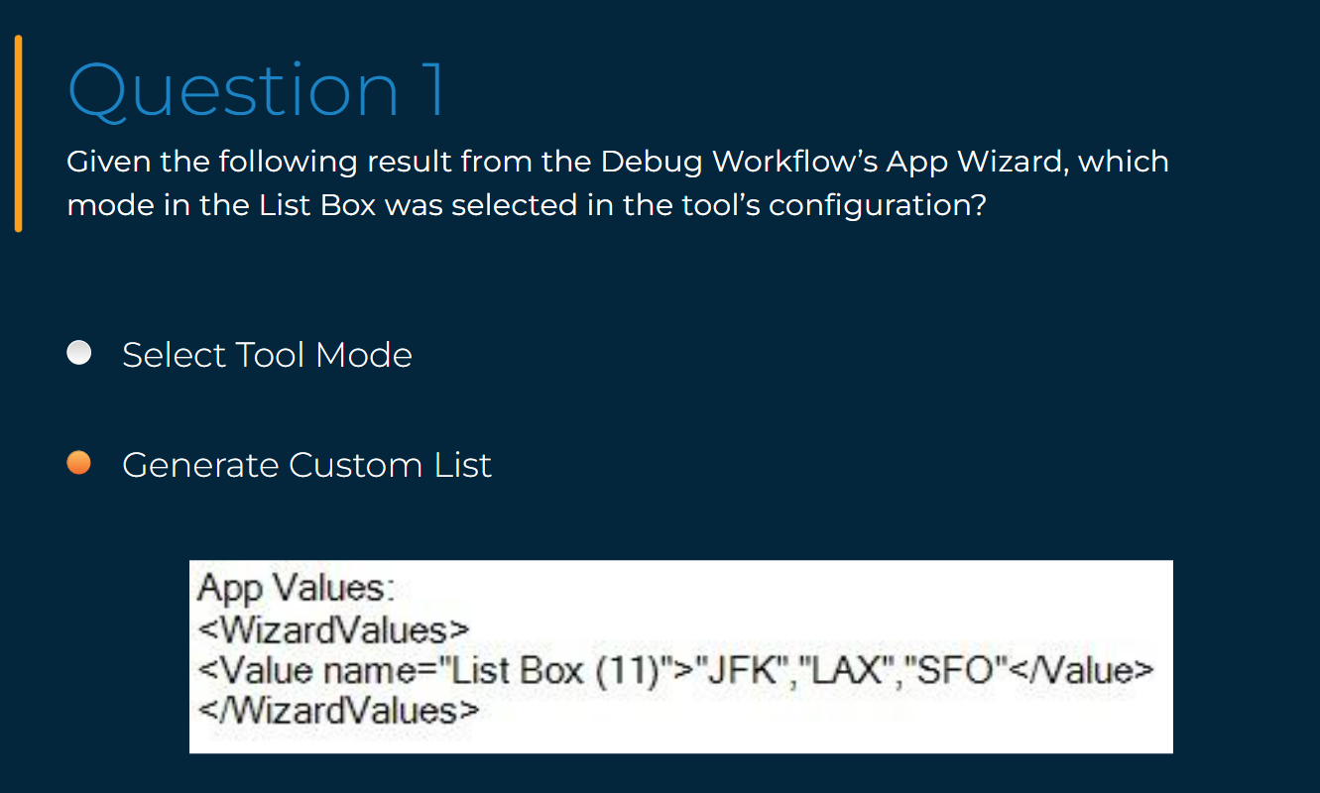

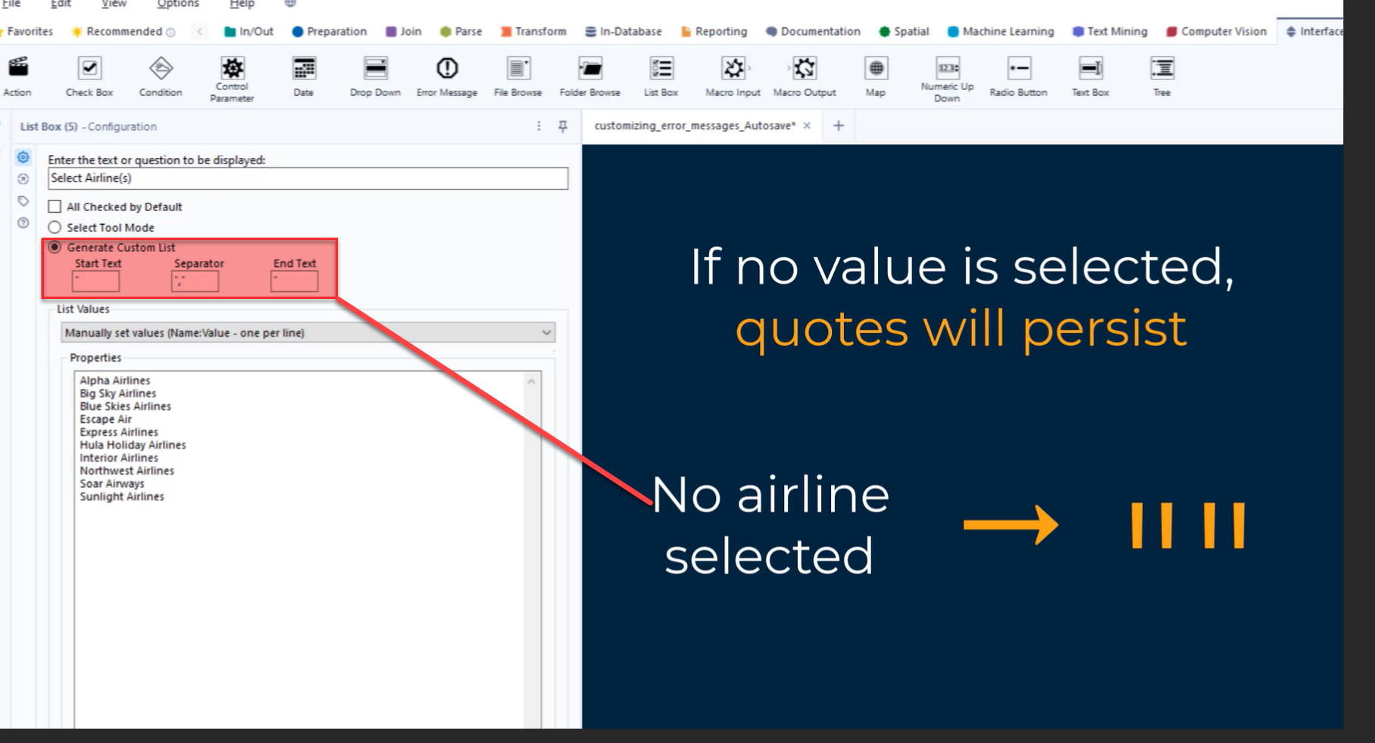

1. Name and value pairs for a chained app may be created using a Summarize tool:

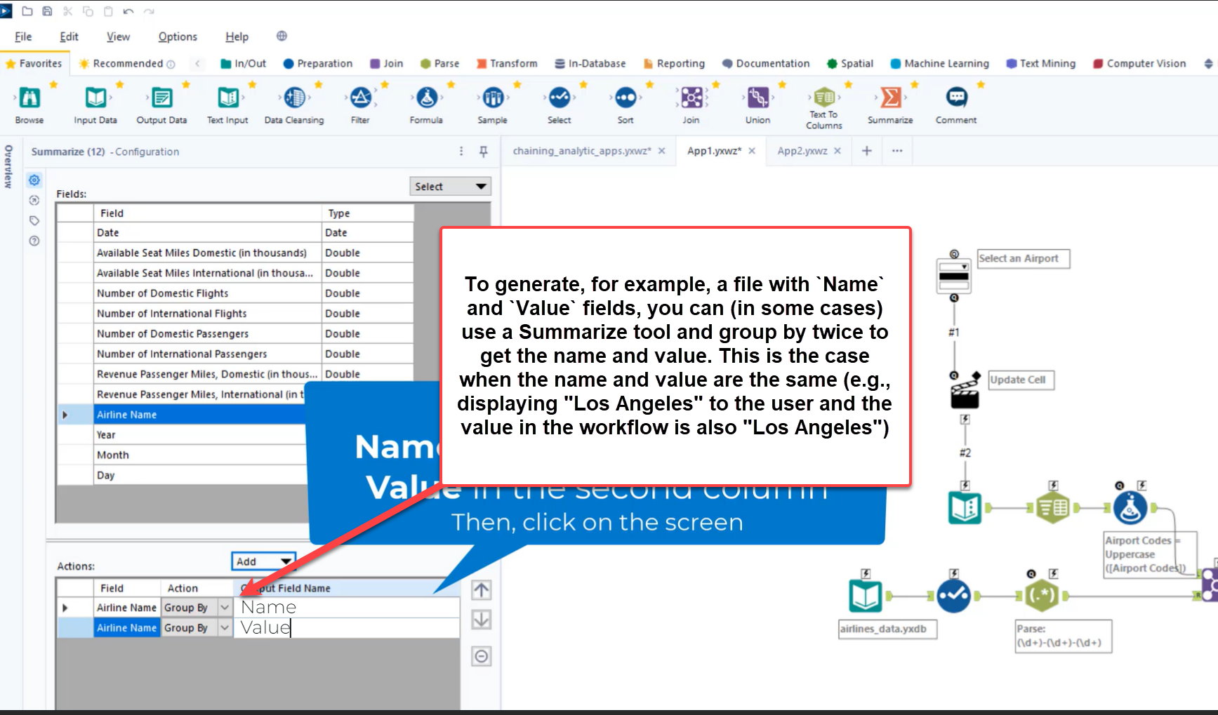

1. [Weekly Challenge #12: Creating an HR Hierarchy](https://community.alteryx.com/t5/Weekly-Challenge/Challenge-12-Creating-an-HR-Hierarchy/td-p/36740)
2. [Building an R Macro](https://community.alteryx.com/t5/Archived-Training/Building-a-R-Macro/td-p/46567)
3. [Using the Data Cleansing Macro](https://community.alteryx.com/t5/Archived-Training/Using-the-Data-Cleansing-Macro/td-p/43856)
4. [Santa's First Iterative Macro](https://community.alteryx.com/t5/Archived-Training/Santa-s-First-Iterative-Macro/td-p/92237)
5. [Weekly Challenge #123: When will Rabbits Rule the World?](https://community.alteryx.com/t5/Weekly-Challenge/Challenge-123-When-will-Rabbits-Rule-the-World/td-p/179283)

# Spatial

1. [Weekly Challenge #204: Updating Brazil](https://community.alteryx.com/t5/Weekly-Challenge/Challenge-204-Updating-Brazil/m-p/532468)
2. Trade Area tool:

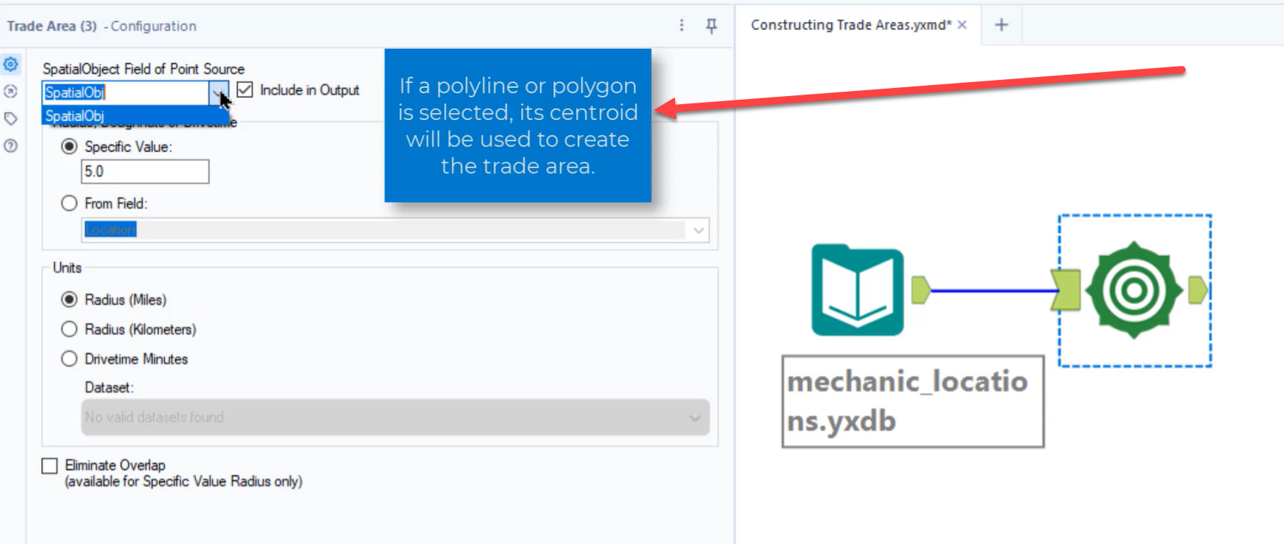

1. Concentric circles in the Trade Area tool: Each larger Trade Area **includes** the smaller Trade Area(s) when using the descending value order, comma separated approach. To create non-overlapping Trade Areas, use a hyphen to separate your Trade Areas (e.g., 5,5-10,10-15). Note that you don’t have to follow that specific format. Another example is 1, 3, 5-7.

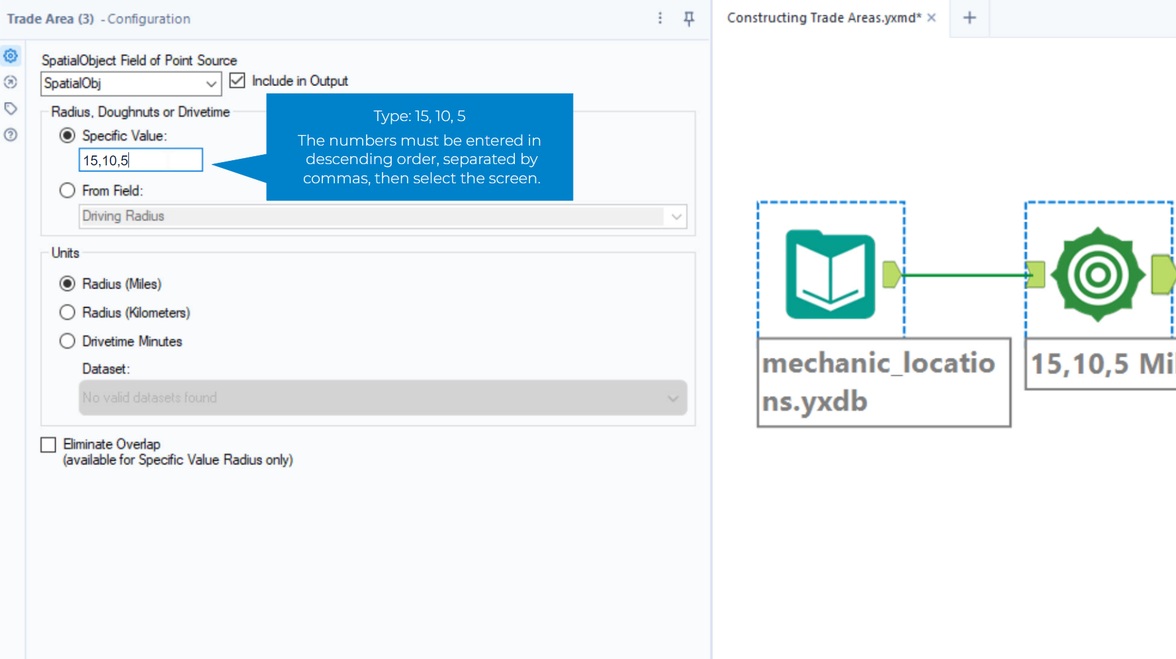

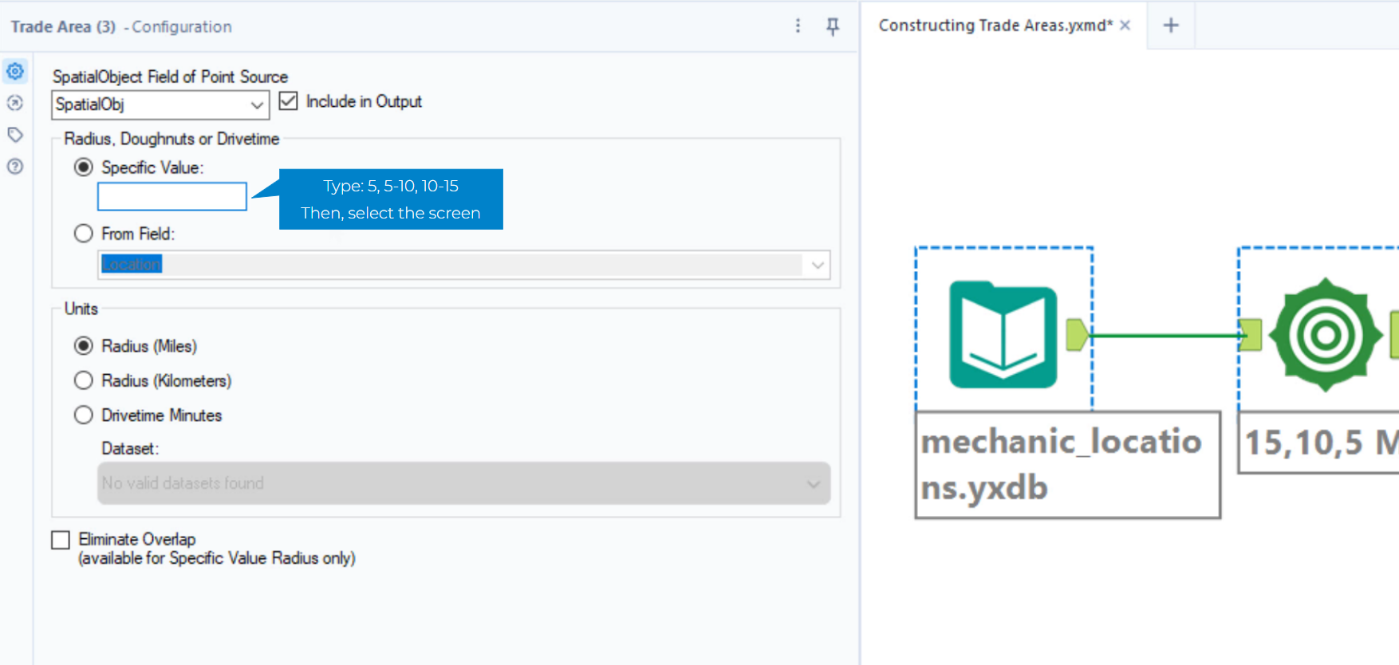

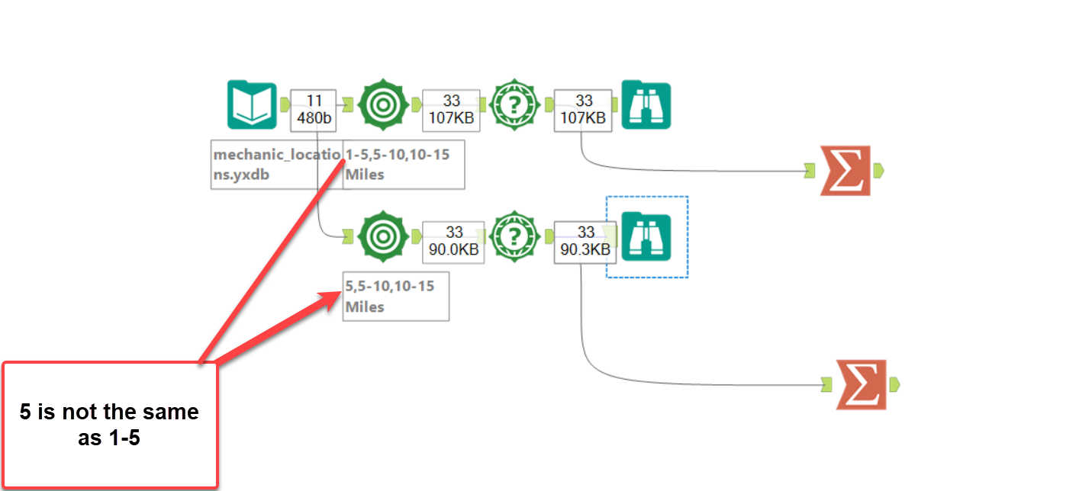

1. [Dimension](https://en.wikipedia.org/wiki/Dimension)
2. Spatial object details from the Browse tool

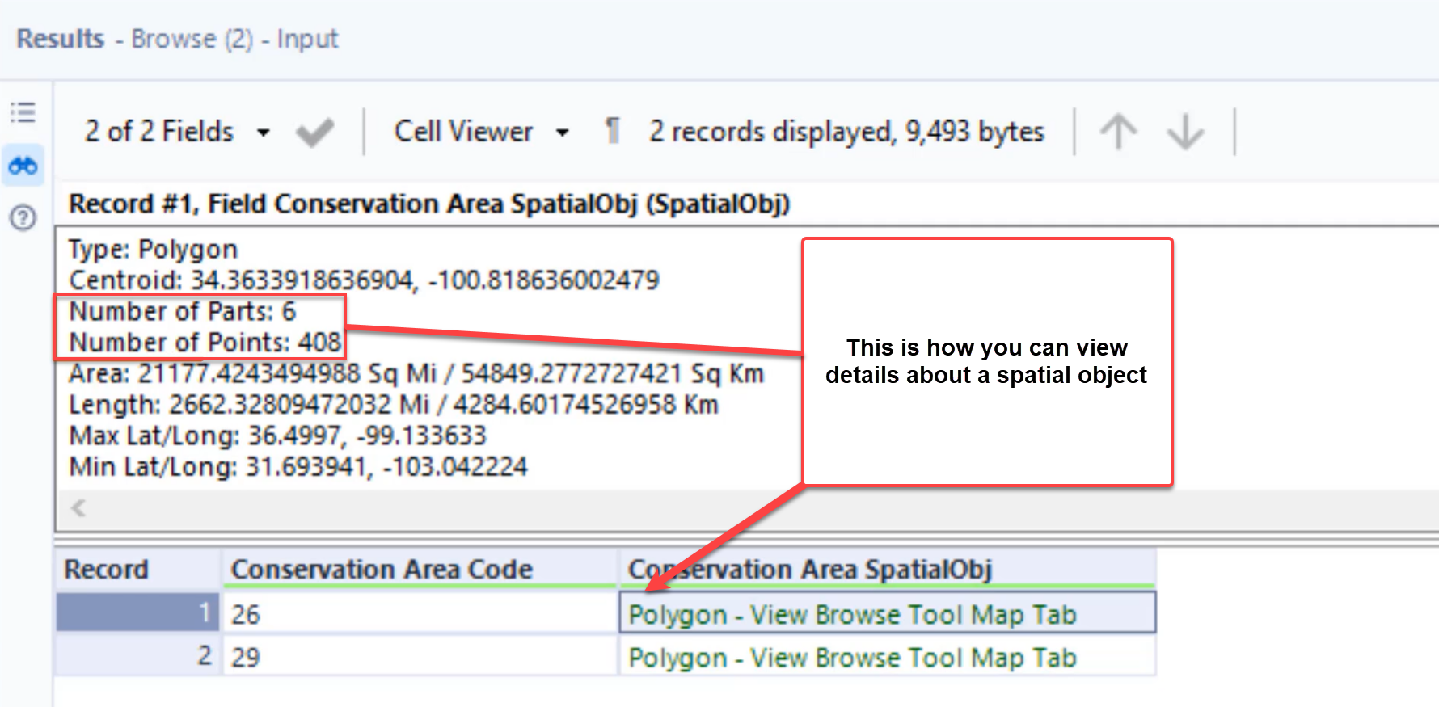

1. Poly-Split tool’s regions vs. detailed regions

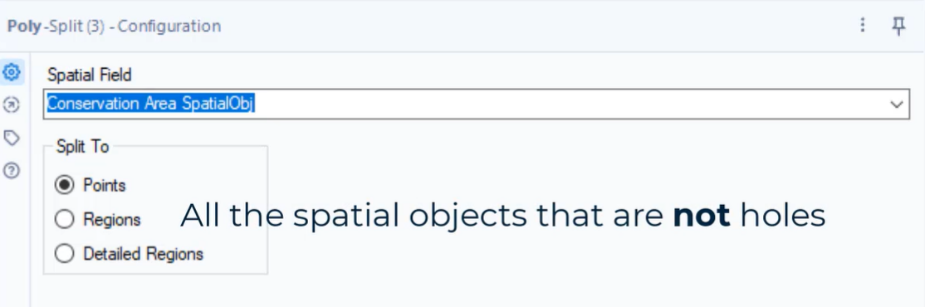

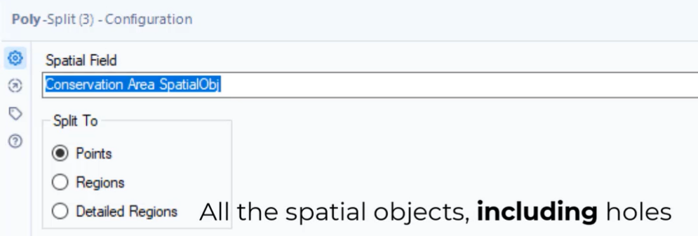

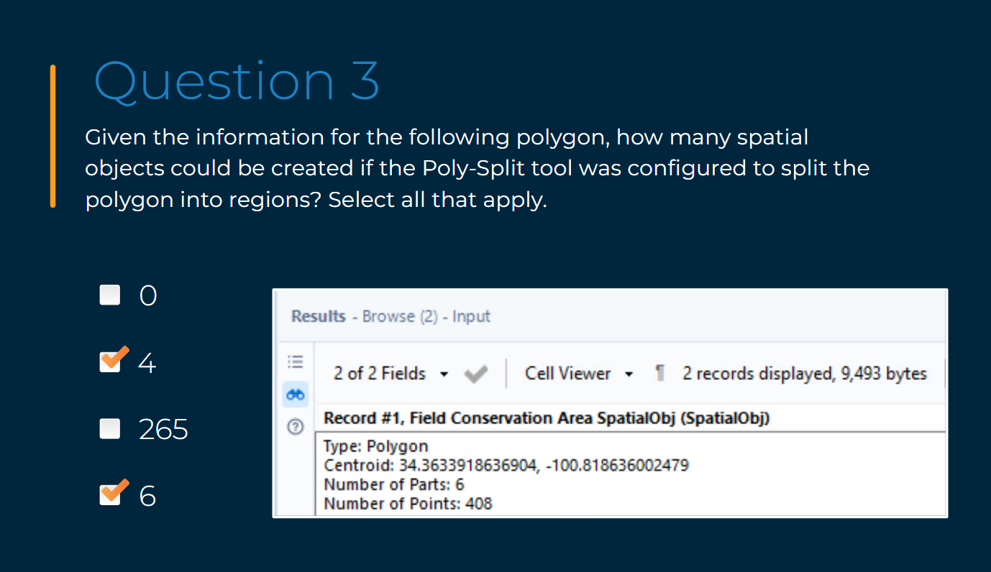

1. In the Browse tool, the source used in a Distance tool is shown in pink and the destination is shown in green.

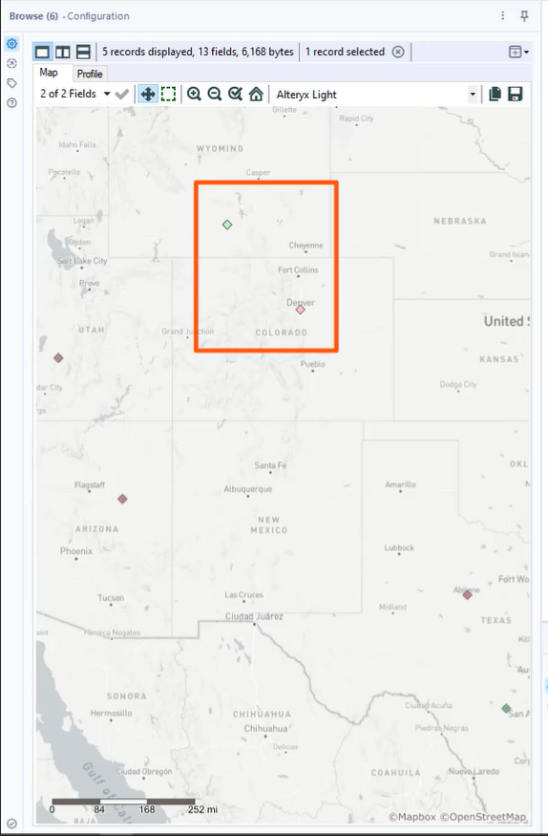

1. Only spatial objects of the same type, such as two polygons, can be combined. Combining a point and a line will produce a [Null]. If you use have two different types of spatial objects (e.g., a line and a polygon) that intersect, the simpler spatial object (in this example, a line) will be returned.

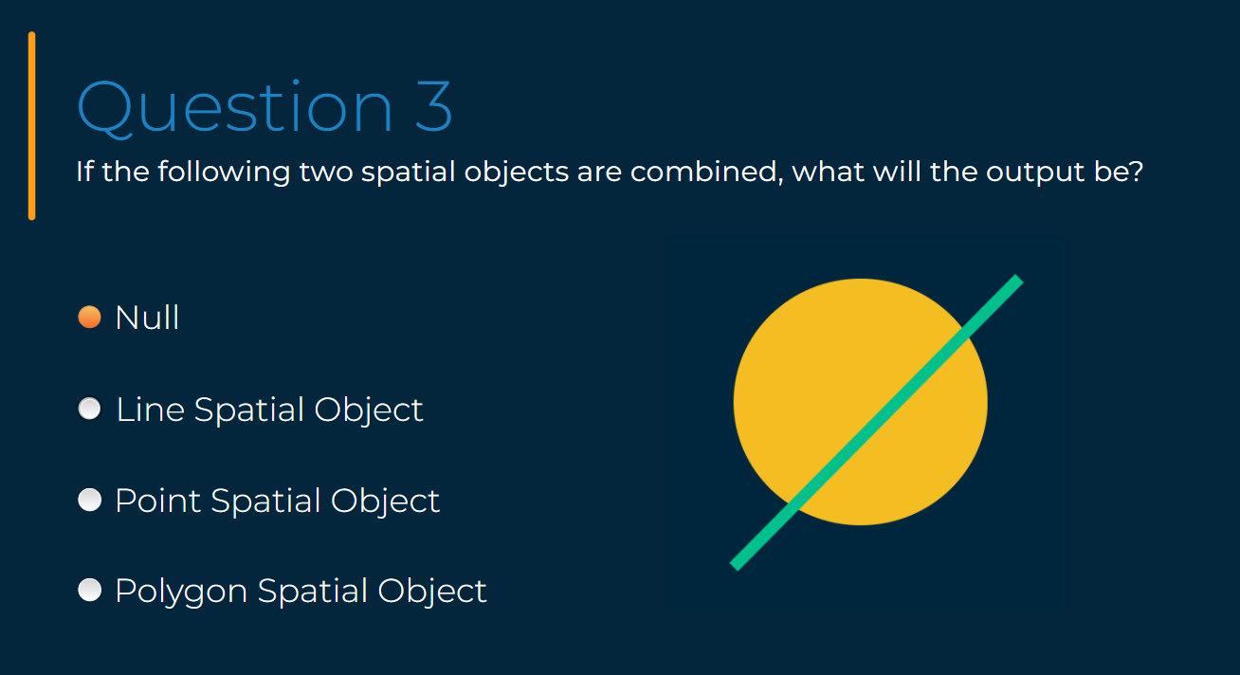

1. Spatial relationships

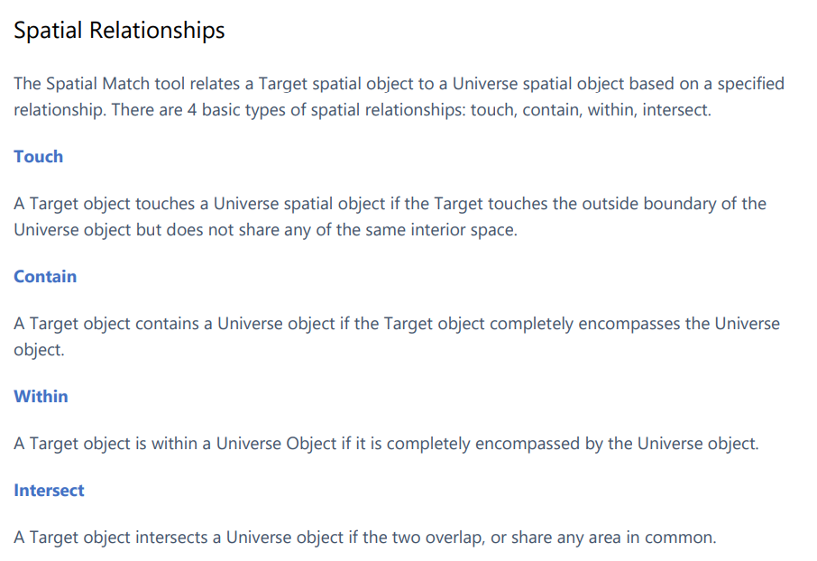

1. [Intermediate Spatial Analytics](https://community.alteryx.com/t5/Archived-Training/Intermediate-Spatial-Analytics/td-p/823123)

# Reporting

1. An example of using a group by within the Table tool

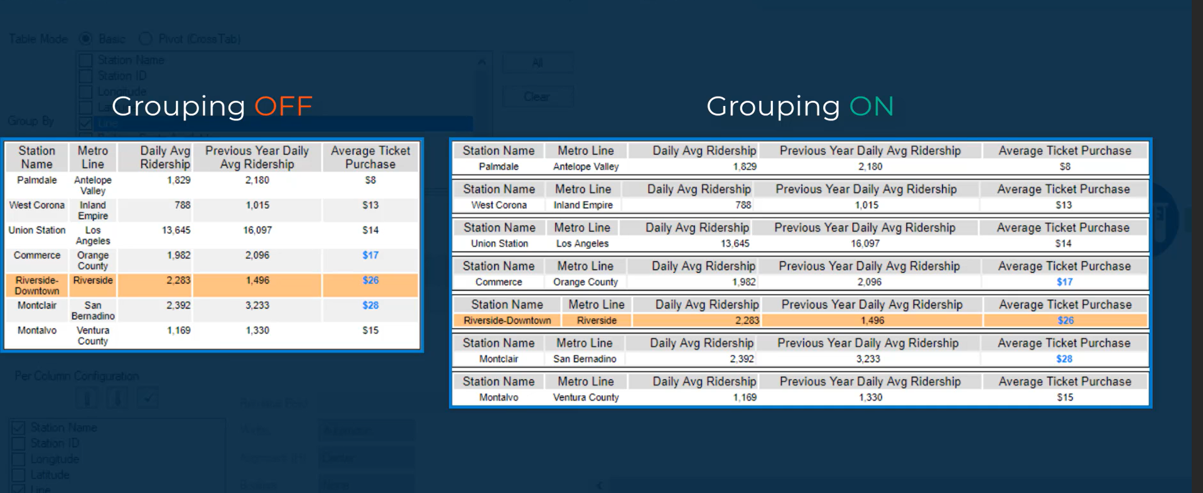

1. Report Map

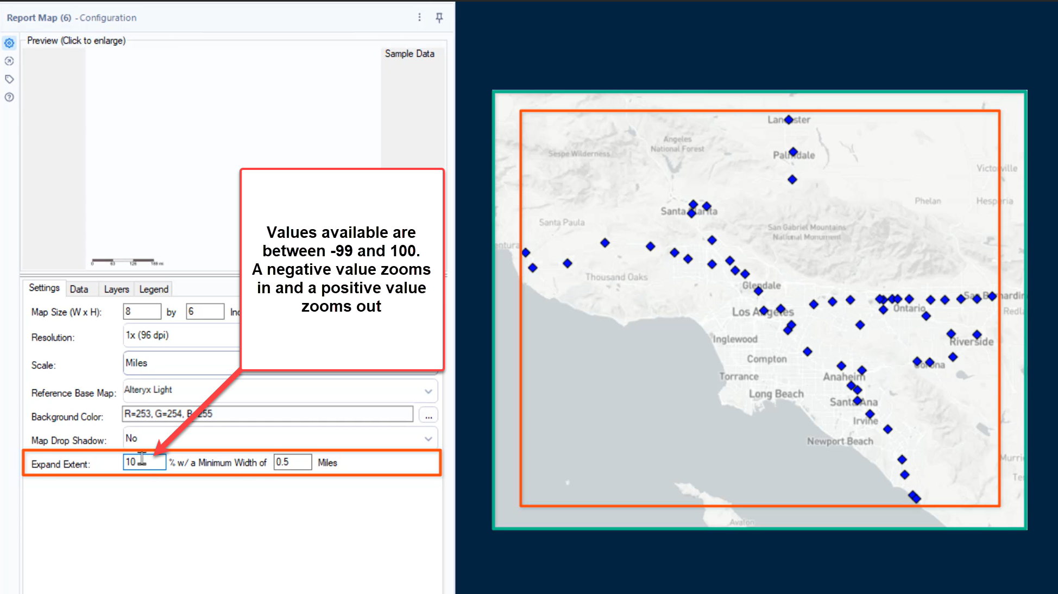

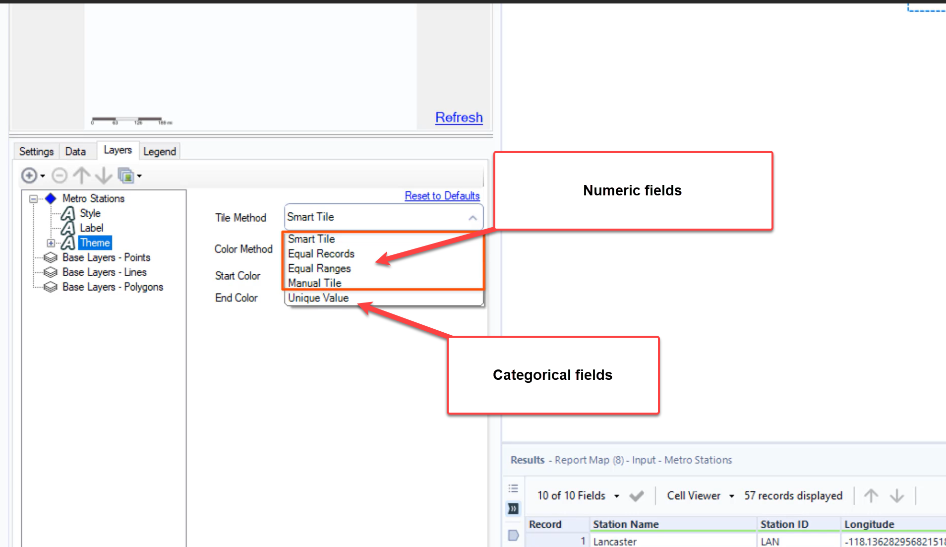

1. Layout

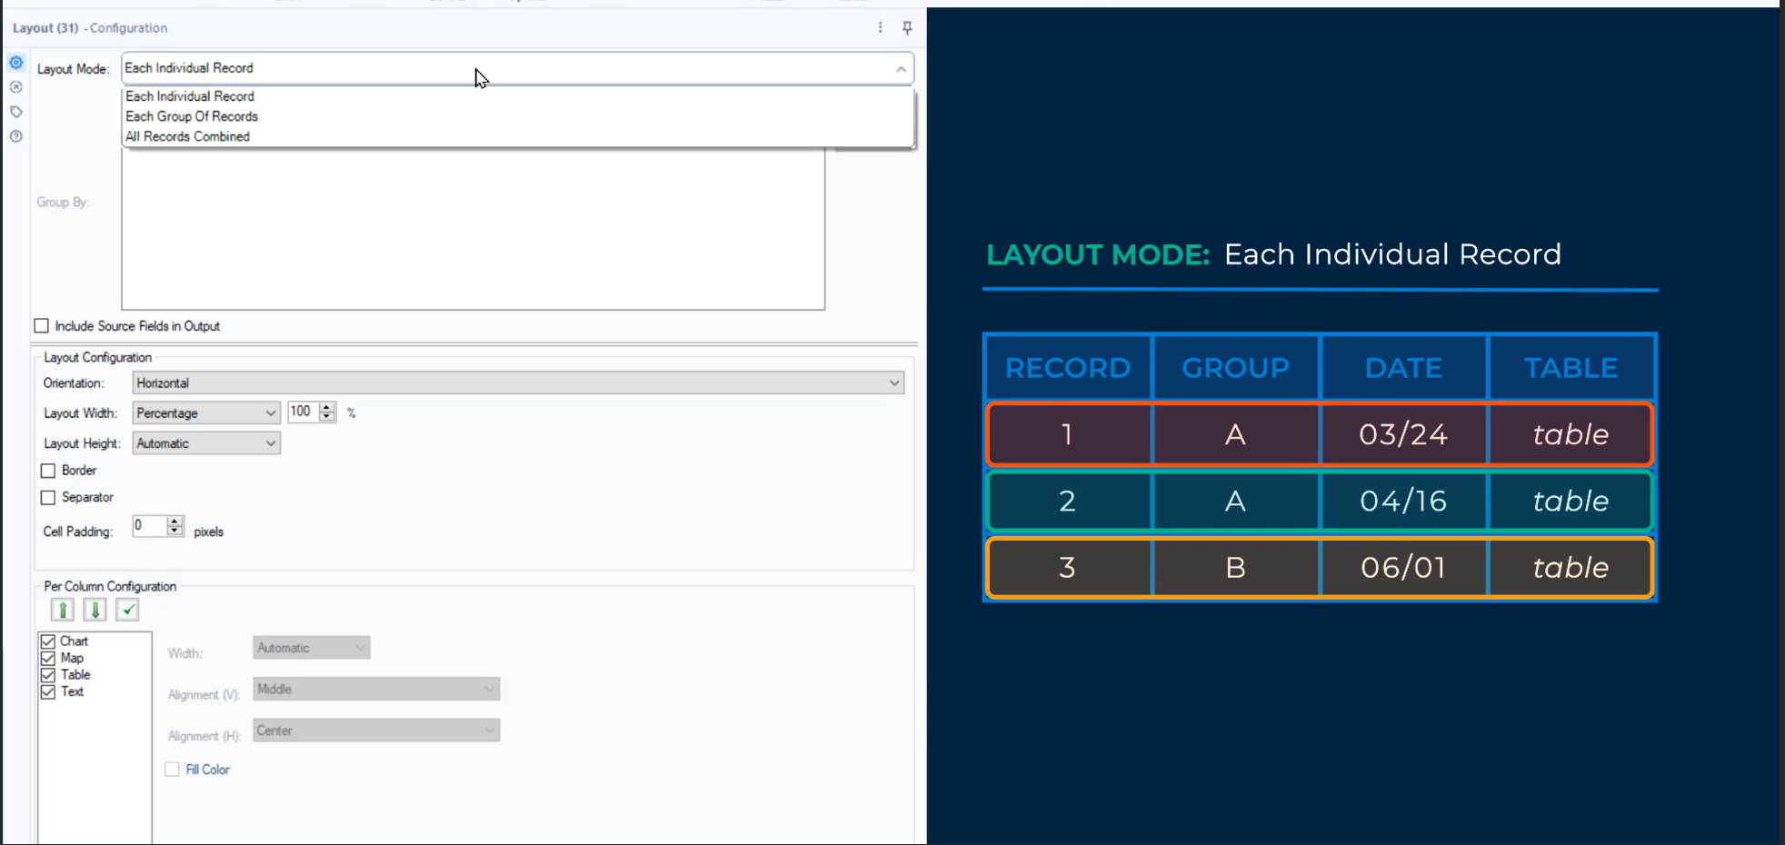

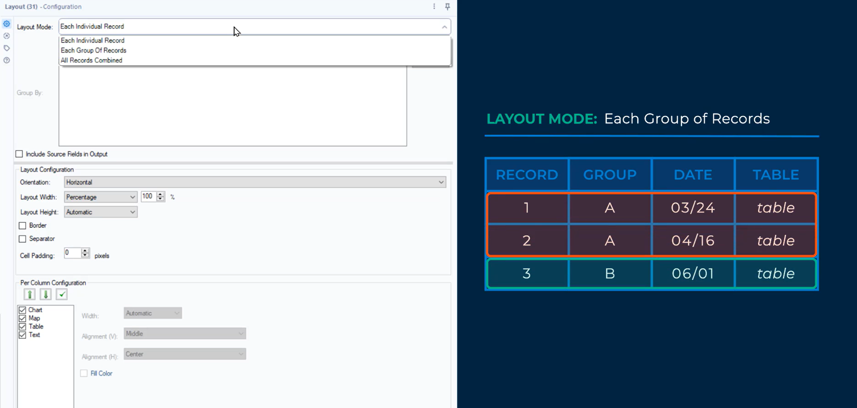

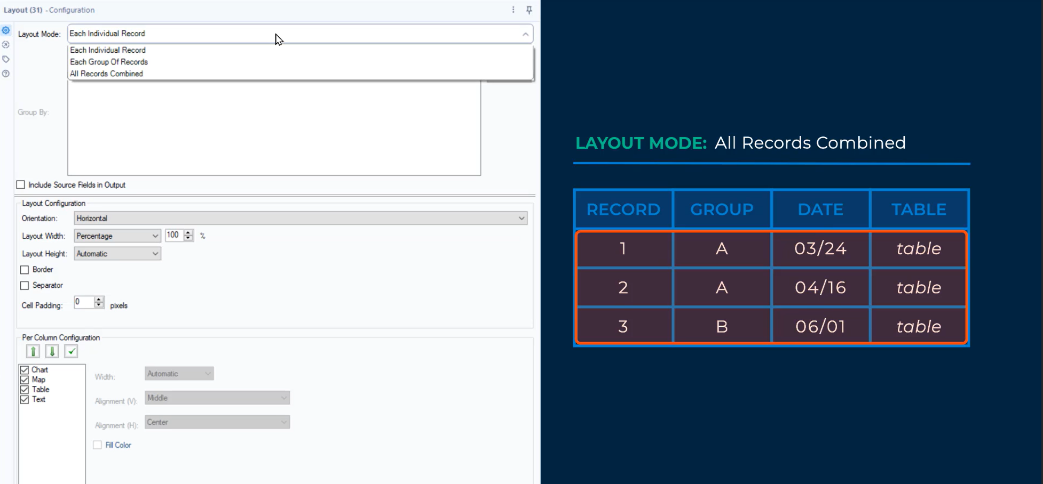

1. [Getting Started with Batch Reporting](https://community.alteryx.com/t5/Archived-Training/Getting-Started-with-Batch-Reporting/td-p/56999)
2. [Getting Visual with Reporting](https://community.alteryx.com/t5/Archived-Training/Getting-Visual-with-Reporting/td-p/822532)
3. [Batch Reporting: Building Tailored Reporting Processes](https://community.alteryx.com/t5/Archived-Training/Batch-Reporting-Building-Tailored-Reporting-Processes/td-p/823104)